NOTE: LETTER TO SCHOOLS TAKING SURVEYS only

DATE

<Principal Title and Name>
< School3> or <School4>
<Address>
<City, State Zip>

Dear Principal:

The XXX is asking for your help in gauging the current status of effective technology use and technology readiness of Oregon schools. The information will be used to drive future initiatives in PreK-12 educational technology. We are piloting a tool to collect data that will give us valuable information to use as we revise our State Educational Technology Plan and to meet accountability measures required under NCLB.

You have been selected as a part of a representative sample (15%) of Oregon districts and select schools within those districts asked to complete surveys between April 22 – May 6, 2004. The directions for selecting a representative sample of teachers who will participate, and the actual steps in taking the surveys are included on the enclosed documents.

If you or any of your staff have any questions about this visit or its purpose, please do not hesitate to contact Carla Wade at 503.378.3600, Ext. 2283 or carla.wade@state.or.us.

I would like to thank you in advance for participating in this data collection effort. Within a few weeks following the completion of this process, your school will be able to go online and see a summary report of their school. No schools will be mentioned by name in the state report.

This data collection effort will position the state of Oregon to strategically move forward in providing resources and leadership to Oregon schools in the important area of technology, learning, and leadership. Thank you for your contribution to this effort.

Sincerely,

SIGNATURE

Enclosures
July 31, 2026

<School Name>

Dear Principal:

Your school has been selected to participate in the surveys only. You, as a principal, and 5 of your teachers, are being asked to take the 20-30 minute survey online. The instructions for accessing the survey are included below, and teacher instructions are enclosed. The surveys can be taken any time between April 22 and May 6. As instructed below, each user will create an email ID and password as part of the login process. This will allow participants to leave partially completed surveys and return to them later, and will also provide for the emailing of lost passwords. No teacher names will be associated with any record. All surveys - teacher and building - will be treated as anonymous data in the final report.

Between the dates of April 22 and May 6:

- Principal Survey

  - Use an Internet Browser to access the SETDA/Metiri web site: http://setda.metiri.com. You will come to the screen below. Click “Take a Survey”
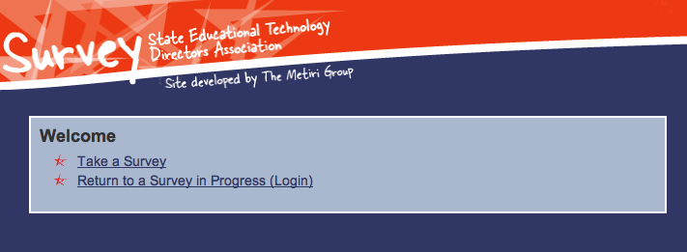

  - On the next screen (see below), enter your survey token: <Building Token>
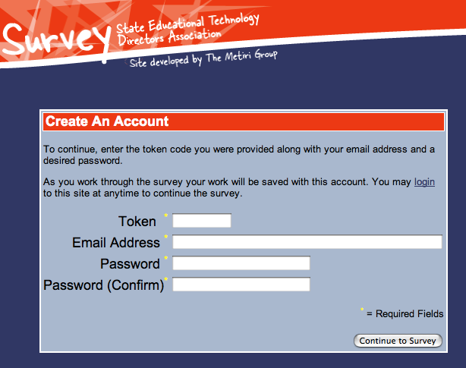

  - Enter your email address as a user ID and create and confirm a password. This will allow you to return to any unfinished survey items.

  - Be sure to record this information in case you want to return to the site to complete the survey or change an entry.

  - Take the survey. Click “Next” to continue to the next item, “Save” to save progress and return later.

- Teacher Survey

  - Randomly identify 5 of your teachers to take the survey by following these simple steps:
    - Alphabetize a list of all your teachers (no specialists, just content area teachers)
    - Divide the number of teachers by 5
    - Start with the teachers’ name at the top of the list and count off by the number from step ii. Those are the teachers who will take the survey

  - The teachers will use an Internet Browser to access the SETDA/Metiri web site: http://setda.metiri.com (see Teacher Survey Instructions, enclosed).

  - Each teacher will enter the same token: <Teacher Token> to create personal logins.

  - Be sure to have teachers record this information in case they want to return to the site to complete the survey or change an entry.

If you or any of your staff have any questions about this visit or its purpose, please do not hesitate to contact:

Carla Wade
Technology Education Specialist
Oregon Department of Education
255 Capitol St. NE
Salem, OR 97310
Ph: 503.378-3600 x2283
FAX: 503.378.5156
E-mail: carla.wade@state.or.us

Thank you in advance for fully participating in this data collection effort. Within a few weeks following the completion of this effort, your staff will be able to go online and see your school’s summary report. Again, no schools or teachers will be mentioned by name in the state report.

This data collection effort will position the state of Oregon to strategically move forward in providing resources and leadership to Oregon schools in the important areas of technology, learning, and leadership. Thank you for your contribution to this effort.

Enclosures:

Teacher Survey Instructions (below)

Taking the Teacher Survey

Between the dates of April 22 and May 6:

- Use an Internet Browser to access the SETDA/Metiri web site: http://setda.metiri.com. You will come to the screen below. Click “Take a Survey”

- On the next screen (see below), enter your survey token <TeacherToken> Note: All teachers in your school may use the same token to establish individual logins.

- Enter your email address as a user ID and create and confirm a password. This will allow you to return to any unfinished survey items. No personal identifying information will be kept when the survey is submitted to the database.

- Be sure to record this information in case you want to return to the site to complete the survey or change an entry.

- Click on “Continue to survey.”

- Once in the survey, Click “Next” to continue to the next item, “Save” to save progress and return later.

