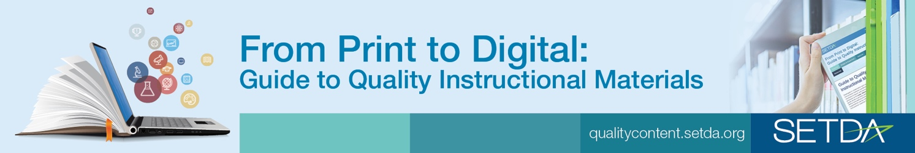

The From Print to Digital: Guide to Quality Instructional Materials identifies key questions and considerations, action steps and best practices for the selection of instructional materials, including both core-instructional materials and supplemental resources.
Essential Question How do schools and districts choose quality instructional materials?
Why Use This Guide?
Today’s instructional materials include resources delivered via different delivery platforms and carrying different types of licenses. However, the criteria used to judge quality and alignment to state learning standards needs to be the same regardless of whether the materials are print or digital, open, or all rights reserved copyright. Quality is quality. This guide may be used to:
Quality instructional materials are content-rich materials aligned to standards that are fully accessible and free from bias. They support sound pedagogy and balanced assessment to help teachers understand and interpret student performance. – SETDA

- Provide guidance to schools, districts and states regarding the selection of instructional materials
- Inform instructional materials adoption policies and ongoing review processes at the state level
- Encourage state leadership as related to instructional materials selection and procurement
- Inform the private sector with an outline of considerations regarding the instructional materials selection and adoption process
- Share resources for a variety of stakeholders involved in the process of selecting instructional materials
How to Use this Guide
State, district and school level leaders can use this guide to launch and maintain vetting processes for the selection of quality instructional materials aligned to standards. Key considerations, questions, action steps and helpful hints are included throughout the guide. Additionally, the guide includes best practice examples from states and districts and national, state and local resources to consider when selecting quality instructional materials. SETDA identifies the key steps in the process as educators embark upon this effort:
Online Community
Join the Digital Content for Learning Community for Resources and Discussions
http://www.edweb.net/digitalcontent
- Planning
- Budget & Funding
- Selection
- Implementation
- Effectiveness

This guide was developed in collaboration with state and district leaders, including instructional materials coordinators and academic officers and leaders from the private sector with the generous support of the Bill and Melinda Gates Foundation.

