TEACHER PREPARATION COMMUNICATION TOOLKIT
This toolkit is to support both faculty and preservice teachers that are part of educator preparation programs (EPP) via both institutions of higher education programs and non-traditional preparation programs. Exploring the knowledge, skills and dispositions required of teachers working in digital age classrooms, this resource is poised to positively impact new teacher experiences and student learning opportunities. This toolkit includes a communications packet with sample documents that are customizable for EPP to use with your faculty and preservice teachers.

LEARNING IN THE DIGITAL AGE
Technology is an essential component of learning today. With digital applications, tools and resources, students can create content, interact with experts, collaborate with peers and participate in simulation activities. Personalized experiences put students at the center of learning and empowers students to take control of their own learning through flexibility and choice. The Every Student Succeeds Act (ESSA) acknowledges technology’s role in revolutionizing learning and includes definitions for digital learning and blended learning, and references technology throughout the legislation. The Non-Regulatory Guidance Student Support and Academic Enrichment Grants publication provides an overview of activities LEAs may consider as they prepare for implementation of the effective use of technology (ESEA Section 4109). Specific activities include: supporting high-quality professional development for educators, school leaders, and administrators to personalize learning and improve academic achievement; building technological capacity and infrastructure; carrying out innovative blended learning projects; providing students in rural, remote, and underserved areas with the resources to benefit from high-quality digital learning opportunities; and delivering specialized or rigorous academic courses and curricula using technology, including digital learning technologies. Similarly, the National Education Technology Plan (NETP) calls for a “revolutionary transformation rather than evolutionary tinkering” in education and recognizes that we must leverage technology to provide engaging and powerful learning experiences for all students. Technology offers all students – urban, rural, low-income, ESL, special needs, high achieving – the opportunity to engage in dynamic learning activities. Education leaders at the federal, state, and local level have the opportunity to provide leadership to ensure that all students have personalized, engaging learning experiences.

ROLE TO SUPPORT LEARNING IN THE DIGITAL AGE
As schools move towards digital learning environments, it is necessary to ensure that preservice teachers gain the knowledge and skills required for teachers working in digital age classrooms. Through modeling of digital learning instruction, EPP faculty members play a significant role for achieving that goal. The Council for Accreditation of Educator Preparation (CAEP) in its Content and Pedagogical Standard states that “Providers ensure that candidates model and apply technology standards as they design, implement and assess learning experiences to engage students and improve learning; and enrich professional practice.” The National Association of State Boards of Education report, Born in Another Time, highlights the need for shifts in teacher preparation programs to support digital learning. Digital natives are not necessarily more likely to include the use of technology tools and resources in the classroom simply because they leverage them for personal use. Teachers that are best prepared for digital learning environments are immersed with digital tools and resources during their own educational experiences and understand the value of digital tools and resources for student learning.

KEY AREAS FOR EPPs
This section highlights some of the key areas of interest for EPPs, including professional learning and best practices.

Professional Learning
As a faculty member of an EPP, how can we prepare preservice teachers for learning in the digital age?

Bridging the gap between teacher preparation programs and school systems is critical so that novice teachers are prepared for success in digital age classrooms. EPPs and school districts can support teacher preparation faculty by sharing innovative models for digital learning implementation to prepare preservice teachers for learning in the digital age. For example, the Substitution Augmentation Modification Redefinition (SAMR) model provides a method for how technology impacts teaching and learning. As teachers progress to the redefinition stage in the model, technology supports student centered learning through student generated discussions and collaboration. The Technological Pedagogical Content Knowledge (TPACK) framework addresses the interplay of three primary forms of knowledge--content, technological and pedagogical. Scholars argue that good teaching requires an understanding of how technology relates to the pedagogy and content. The Innovation Exchange (developed by the American Association of Colleges for Teacher Education) is a vehicle for EPPs to share their innovative approaches, new technologies, and transformative practices in educator preparation. The Innovation Exchange promotes interaction and collaboration within the professional community.

Learn more about professional learning

Professional Learning Toolkit

Best Practices

What are some of the best practices for EPP faculty and preservice teachers?

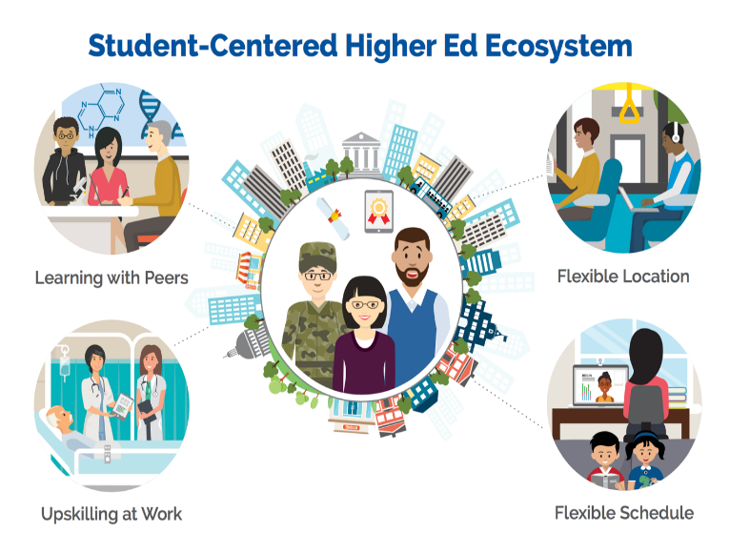
The U.S Department of Education (ED) encourages Institutions of Higher Education (IHE) to shift to student-centered learning models supported by digital tools and resources for all disciplines. The recently published report, Reimagining the Role of Technology in Higher Education proposes a student-centered higher ed ecosystem—depicted in the accompanying graphic. If future educators in teacher preparation programs experience student-centered learning via digital tools they are more likely to integrate such practices in their classrooms.

In addition, ED published the Advancing Educational Technology in Teacher Preparation: Policy Brief, which identifies key challenges and solutions to the effective integration of technology in teacher preparation, provides guiding principles on how to move the field toward effective integration of technology in teacher preparation programs, and identifies areas of opportunity and collaboration for stakeholders across the field.

Learn more about best practices for EPPs

Advancing Educational Technology in Teacher Preparation: Policy Brief

Reimagining the Role of Technology in Higher Education

TRANSFORMING DIGITAL LEARNING

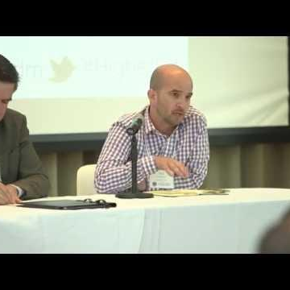

Reimagining Higher Education Convening
Paul Freedman, founder and CEO of Entangled Ventures, discusses their work with higher education institutions to develop new models.
https://youtu.be/kAKxfFUQY4U

Digital Equity and Teacher Preparation: Improving the K–12 Teaching Pipeline
This video focuses on the role of partnerships between K-12 schools and institutions of higher education (IHE’s) in training new teachers to use technology effectively.
https://youtu.be/V9zNs5w-vjw

Teachers Create what they Experience
Create a shared vision of teaching and learning. Using learning as a process and not an event. Allow authentic learning through practice, trail, and authentic activities. https://youtu.be/rcDpDPwRxvU

COMMUNICATION PACKET
The communication packet includes customizable templates. Partners can add logos,
examples or other resources to help engage stakeholders and support this topic. Users are encouraged to leverage these resources to support your work in engaging faculty and preservice teachers by providing them with the resources needed to create an ecosystem of support and learning inside and outside of school walls.
- Newsletter/website snapshot
- Presentation slides to support conversations with stakeholders
- Social media promotion examples
- Press outreach
- Outreach email

