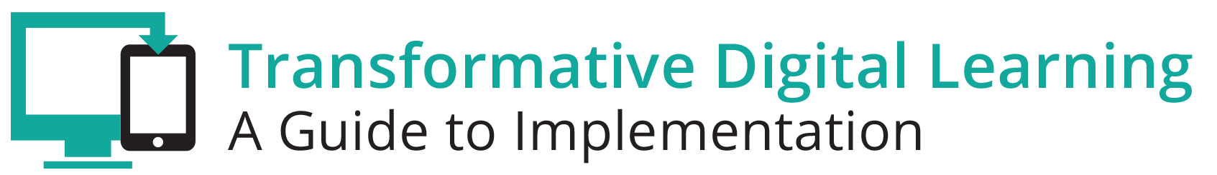

STUDENT COMMUNICATION TOOLKIT
This toolkit describes how digital learning can support students to help ensure college and career readiness. Effective digital learning environments are dependent upon successful student learning and achievement. Many students have embraced technology tools and resources in their personal lives—whether it’s engaging in social media, self-directed learning (outside of class assignments), listening to music, gaming, or video chatting with friends. Current business and workforce requirements demand the use of technology tools and resources from clerks to mechanics to artist to engineers to physicians. Educators are encouraged to share this toolkit with students to inform them about the benefits of a digital learning environment, as well as some areas of concern. This resource includes a communications packet with sample documents that are customizable for you to use as you support students in learning in the digital age.

LEARNING IN THE DIGITAL AGE
Technology is an essential component of learning today. With digital applications, tools and resources, students can create content, interact with experts, collaborate with peers and participate in simulation activities. Personalized experiences put students at the center of learning and empowers students to take control of their own learning through flexibility and choice. The Every Student Succeeds Act (ESSA) acknowledges technology’s role in revolutionizing learning and includes definitions for digital learning and blended learning, and references technology throughout the legislation. In the Non-Regulatory Guidance Student Support and Academic Enrichment Grants publication provides an overview of activities LEAs may consider as they prepare for implementation of the effective use of technology (ESEA Section 4109). Specific activities include: supporting high-quality professional development for educators, school leaders, and administrators to personalize learning and improve academic achievement; building technological capacity and infrastructure; carrying out innovative blended learning projects; providing students in rural, remote, and underserved areas with the resources to benefit from high-quality digital learning opportunities; and delivering specialized or rigorous academic courses and curricula using technology, including digital learning technologies. Similarly, the National Education Technology Plan (NETP) calls for a “revolutionary transformation rather than evolutionary tinkering” in education and recognizes that we must leverage technology to provide engaging and powerful learning experiences for all students. Technology can offer students with various backgrounds and needs – urban, rural, low-income, ESL, special needs, high achieving – the opportunity to engage in dynamic learning activities. Education leaders at the federal, state, and local level have the opportunity to provide leadership to ensure that all students have personalized, engaging learning experiences.

ROLE TO SUPPORT LEARNING IN THE DIGITAL AGE
Effective digital learning environments are dependent upon successful student learning and achievement. Students and student organizations play an important role in the transition to digital learning. Speak Up 2016 reports that students are using mobile devices for a variety of teacher-directed and student directed activities. Survey data shows that 81% of students are doing internet research with their mobile device and 39% report taking notes on their device. Many students see technology as a gateway to personalizing and self-blending learning around areas of interest that are academic or for career preparation purposes.

KEY CONCERNS FOR STUDENTS
This section highlights some of the key areas of concerns that students might encounter as their school implements digital learning. They include digital citizenship and the homework gap.

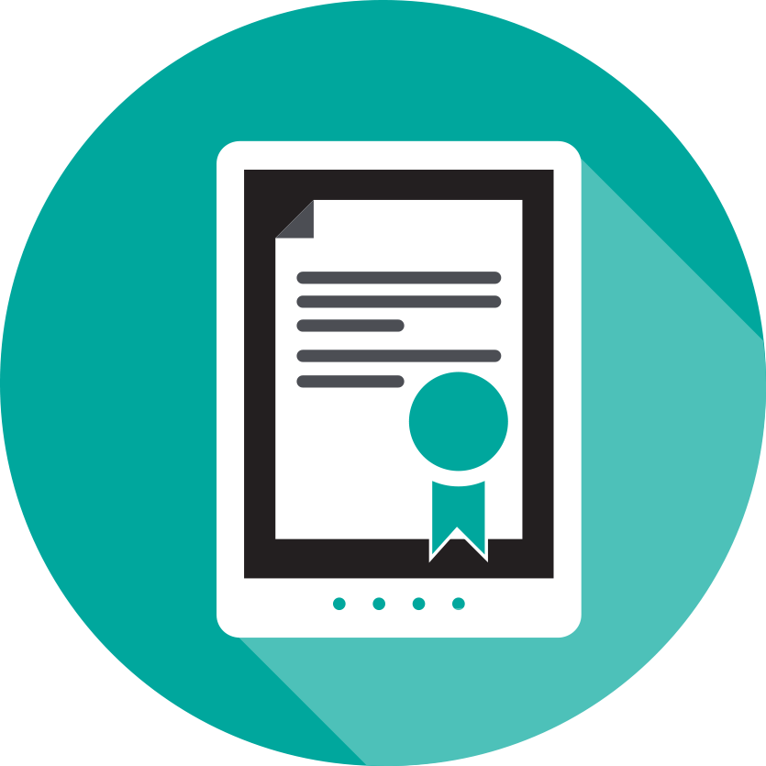
Digital Citizenship

As a student, how can I learn more about my digital footprint?
Effective digital citizenship helps create a positive school culture that supports the safe and responsible use of digital tools and resources. Students can learn how to use technology safely and responsibly from their parents, teachers and librarians. Families and schools are also a good resource for students to learn how to navigate issues of cyberbullying, internet safety, data privacy, digital footprint and other digital concerns.
“Empower your students to make safe, smart and ethical decisions online.”
- Common Sense Education

Learn more about digital citizenship

Common Sense Education Cyberbullying and Digital Footprint

U.S Department of Health and Human Services Cyberbullying

Middle School Digital Citizenship Videos

Digital Citizenship Interactive Games for Students.

High School Digital Citizenship Videos

Safe and Secure Online

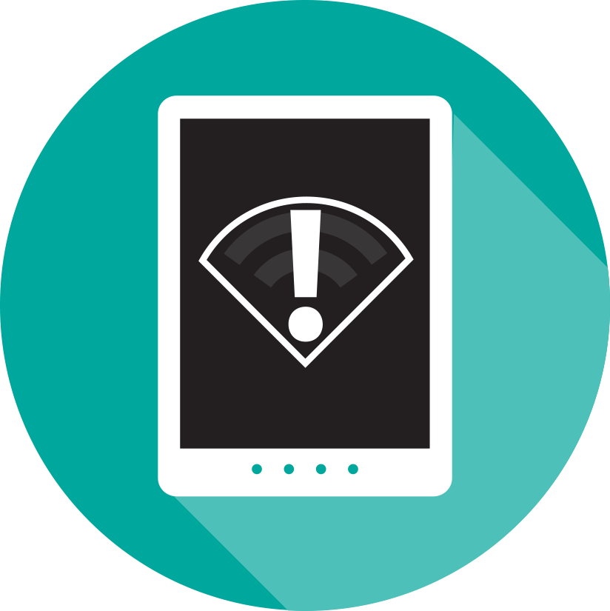
Homework Gap
My teacher assigns homework that requires access to the internet. How can I access the internet outside of my home?

The “homework gap” – the gap between students whose internet connections at home are slow or non-existent—and those who have out of school connections with consistent, adequate speed access to conduct school based activities in a safe environment is an increasingly important issue. As schools implement digital learning and teachers require students to have internet access outside of school, the digital divide is increasing. According to Project Tomorrow’s Speak Up Research Project (2016),17% of students in grades 6-12 say that they sometimes cannot do homework due to the lack of connectivity outside of school. This problem is disproportionately common in rural and underserved communities. Some districts have actively partnered with internet providers in their communities to offer discounted service fees, others issue hot spots that students can take home, while others have adjusted school library hours to offer more access. Public libraries are another option for helping to address the “homework gap”. Many libraries offer access to free wireless internet, computers and devices, and digital resources. The FCC’s Lifeline program is another option for low-income families to acquire discounted broadband service at home.
2/3 of students say that it is important for them to have safe and consistent access to the internet when they are outside of school for them to be successful in school.
Project Tomorrow’s Speak Up Research Project (2015)

Learn more about ways that schools/districts can address the homework gap

Protecting Equity through Family-School Partnerships

FCC Lifeline Program

TRANSFORMING DIGITAL LEARNING

Transforming Digital Learning
Students in Black Hawk elementary school in South Dakota shows Transforming Digital Learning. https://www.youtube.com/watch?v=NyjsC1x5T54

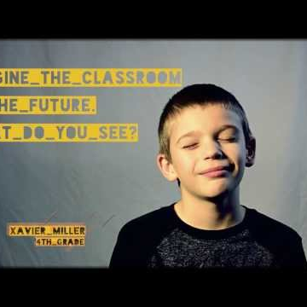

Technology in Classrooms
These students created the video to promote awareness about programs that provide internet access at home since the school could track who had access. This way people could contact a school rep voluntarily to get signed up. https://www.youtube.com/watch?v=2lSscbqRZVM

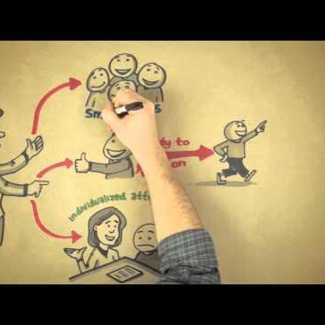

Personalized Learning in Henry County, Georgia
Efforts to personalize instruction for all students in Henry County, GA are well underway thanks to strong district leadership and effective technology planning to achieve higher standards for learning. https://youtu.be/nQutyTP7X2Q

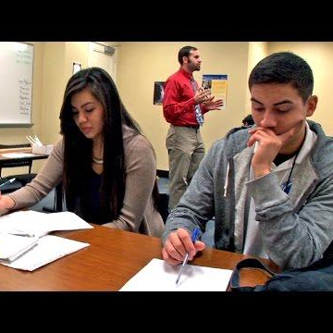
Student Surveys: Using Student Voices to Improve Teaching and Learning
When teachers survey their classes at Trinidad Garza Early College High School, students see how their opinions matter and have a direct impact on instruction. https://youtu.be/cP-8OGwQRPI

COMMUNICATION PACKET
The communication packet includes customizable templates. Partners can add logos, examples or other resources to help engage stakeholders and support this topic. Users are encouraged to leverage these resources to support your work in engaging school librarians by providing them with the resources needed to create an ecosystem of support and learning inside and outside of school walls.
- Newsletter/website snapshot
- Presentation slides to support conversations with stakeholders
- Social media promotion examples
- Press outreach
- Outreach email

For more information about learning in the digital age, please visit XXXX (website).

