SCHOOL LIBRARIANS COMMUNICATION TOOLKIT
This toolkit describes the school librarians’ role in revolutionizing learning in the digital age to help ensure that students are college and career ready. School librarians are instructional leaders and teachers who work closely with other educators and students to facilitate learning. As schools move towards digital learning environments, it is necessary to foster the support of school librarians to advance the transition. Specifically, school librarians provide professional learning opportunities to teachers in the areas of digital citizenship, information literacy, content curation, and the implementation of digital tools and resources. School librarians teach students information literacy skills, digital citizenship and the use of digital tools and applications. School librarian member organizations may want to share this toolkit with members to explain the importance of moving towards digital learning while addressing some of the areas of concern for school librarians as districts and schools transition to learning in the digital age. This toolkit includes a communications packet with sample documents that are customizable for you to use as you support school librarians.

LEARNING IN THE DIGITAL AGE
Technology is an essential component of learning today. With digital applications, tools and resources, students can create content, interact with experts, collaborate with peers and participate in simulation activities. Personalized experiences put students at the center of learning and empower students to take control of their own learning through flexibility and choice. The Every Student Succeeds Act (ESSA) acknowledges technology’s role in revolutionizing learning and includes definitions for digital learning and blended learning, and references technology throughout the legislation. In the Non-Regulatory Guidance Student Support and Academic Enrichment Grants publication provides an overview of activities LEAs may consider as they prepare for implementation of the effective use of technology (ESEA Section 4109). Specific activities include: supporting high-quality professional development for educators, school leaders, and administrators to personalize learning and improve academic achievement; building technological capacity and infrastructure; carrying out innovative blended learning projects; providing students in rural, remote, and underserved areas with the resources to benefit from high-quality digital learning opportunities; and delivering specialized or rigorous academic courses and curricula using technology, including digital learning technologies. Similarly, the 2017 National Education Technology Plan Update (NETP) calls for a “revolutionary transformation rather than evolutionary tinkering” in education and recognizes that we must leverage technology to provide engaging and powerful learning experiences for all students. Technology offers all students – urban, rural, low-income, ESL, special needs, high achieving – the opportunity to engage in dynamic learning activities. Education leaders at the federal, state, and local level have the opportunity to provide leadership to ensure that all students have personalized, engaging learning experiences.

ROLE TO SUPPORT LEARNING IN THE DIGITAL AGE
As schools move towards digital learning environments, it is necessary to foster leadership beyond district and school leaders to support the transition. School librarians play an important leadership role in modernizing educational settings–both at school and in the community. In the digital age, libraries offer a space for students to create content and collaborate, as well as provide access to the internet and digital resources. Beyond digital citizenship, school librarians teach students information literacy skills and the use of digital tools and applications. As school leaders in literacy and technology, school librarians collaborate with classroom teachers and fellow educators to instruct every student in the school community. School librarians support the development of digital learning, participatory learning, inquiry learning, and information and technology literacies with digital and print materials, including curation of openly licensed educational resources.

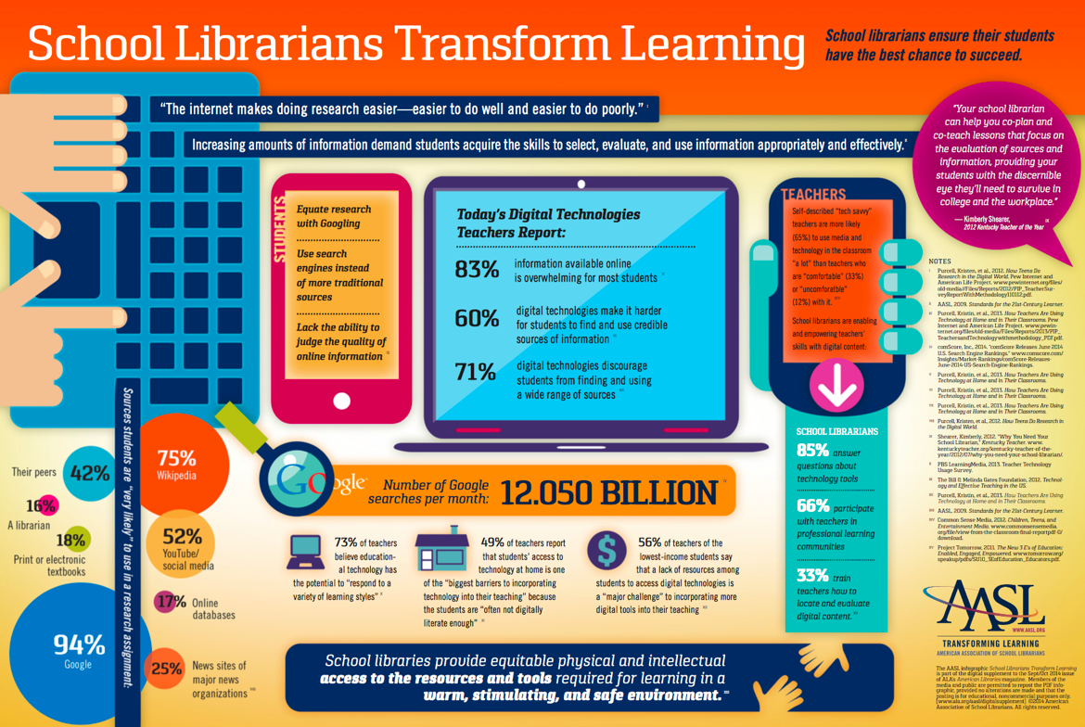

School Librarians Transform Learning

KEY CONCERNS FOR SCHOOL LIBRARIANS
This section highlights some of the key areas of concerns that school librarians might encounter as their school implements digital learning. They include professional learning, digital citizenship and community partnerships.

Professional Learning
Our school is now completely digital for instructional materials. How can I help teachers effectively utilize these materials?

School librarians in the digital age can help teachers locate digital
instructional materials and resources, whether they are paid subscriptions or open and free. Additionally, school librarians can work with teachers to leverage digital tools and resources for lesson planning and instruction. Modeling the integration of digital tools and resources in classroom instruction is another technique used for professional learning. The 2011 School Library Research survey states that 74% of respondents were either fully or partially involved in “collaborating with teachers to use technology in their instruction,” and 80% were involved in “providing teachers with access to technology that enhances their instruction.”

School librarians are leaders who work with every student and every teacher, across the curriculum, for equitable learning opportunities. School libraries offer a well-rounded educational program focused on accessing and evaluating information, digital learning, and a culture of reading. School librarians teach students how to learn, and they help teachers drive student success.
- Sylvia Norton, Executive Director of the American Association of School Librarians

Learn more about professional learning
Professional Learning Toolkit
American Association of School Librarians
2011 School Library Research
From Print to Digital Toolkit

Digital Citizenship

How can school librarians support students around digital citizenship?

Effective digital citizenship helps create a positive school culture that supports the safe and responsible use of digital tools and resources. School librarians are an excellent resource for teachers and students on how to use technology safely and responsibly. School librarians can help students with information literacy – the ability to find, evaluate, interpret, and apply information, encourage collaboration and creation of content, as well as help navigate cyberbullying, internet safety, and other digital concerns.

“Being a good digital citizen is more than knowing your way around the web. It's about connecting and collaborating in ways you didn't even know were possible.”
- Common Sense Education

Learn more about digital citizenship

Common Sense Education Cyberbullying and Digital Footprint

U.S Department of Health and Human Services Cyberbullying

Community Partnerships
How can the school librarian create awareness about digital learning in their school or district?

School librarians can be an advocate for digital learning as they work with principals, teachers, students and parents. Through advocacy and strategic engagement, school librarians can generate public and parental support for digital learning. A simple method for engaging parents is to invite them to the school library to see the digital tools and resources available for their students. Another option is for the school library to host a technology fair where students can showcase projects and/or Transforming Digital Learning. This is an opportunity to invite community members, including local school board members, parent organizations, and local business to promote awareness around the positive impacts of learning in the digital age.

Learn more about community partnerships

Family Online Safety Institute: How to be a Good Digital Parent Toolkit

Digital Learning Day

TRANSFORMING DIGITAL LEARNING

What Do You Predict for the Future of School Libraries
In this video, librarian Sereena Hamm of Washington Latin Public Charter School discusses what she predicts for libraries in the future.
https://www.youtube.com/watch?v=QuI3I9gxxxQ

Changing the Conversations about Librarians
Mark Ray is changing the conversation from "shh..." to "How can I help your with technology?" Mark has helped to overhaul libraries in Vancouver Public Schools in Washington state. https://youtu.be/IniFUB7worY

Good Digital Parenting. In this short video by the Family Online Safety Institute, teens help parents to understand, discuss and encourage the use online privacy settings for their children. https://youtu.be/zBNOb_PvLrw

COMMUNICATION PACKET
The communication packet includes customizable templates. Partners can add logos,
examples or other resources to help engage stakeholders and support this topic. Users are encouraged to leverage these resources to support your work in engaging school librarians by providing them with the resources needed to create an ecosystem of support and learning inside and outside of school walls.
- Newsletter/website snapshot
- Presentation slides to support conversations with stakeholders
- Social media promotion examples
- Press outreach
- Outreach email

