SCHOOL BOARD MEMBERS COMMUNICATION TOOLKIT
This toolkit describes the school boards’ role to support a learning revolution in the digital age that helps ensure students are college and career ready. Specifically, local school boards can work with administrators and educators at the state, district and school levels to support learning through collaborative leadership and community partnerships. This resource includes a communications packet with sample documents that are customizable for you to use as you support school board members.

LEARNING IN THE DIGITAL AGE
Technology is an essential component of learning today. With digital applications, tools and resources, students can create content, interact with experts, collaborate with peers and participate in simulation activities. Personalized experiences put students at the center of learning and empowers students to take control of their own learning through flexibility and choice. The Every Student Succeeds Act (ESSA) acknowledges technology’s role in revolutionizing learning and includes definitions for digital learning and blended learning, and references technology throughout the legislation. The Non-Regulatory Guidance Student Support and Academic Enrichment Grants publication provides an overview of activities LEAs may consider as they prepare for implementation of the effective use of technology (ESEA Section 4109). Specific activities include: supporting high-quality professional development for educators, school leaders, and administrators to personalize learning and improve academic achievement; building technological capacity and infrastructure; carrying out innovative blended learning projects; providing students in rural, remote, and underserved areas with the resources to benefit from high-quality digital learning opportunities; and delivering specialized or rigorous academic courses and curricula using technology, including digital learning technologies. Similarly, the National Education Technology Plan (NETP) calls for a “revolutionary transformation rather than evolutionary tinkering” in education and recognizes that we must leverage technology to provide engaging and powerful learning experiences for all students. Technology offers all students – urban, rural, low-income, ESL, special needs, high achieving – the opportunity to engage in dynamic learning activities. Education leaders at the federal, state, and local level have the opportunity to provide leadership to ensure that all students have personalized, engaging learning experiences.

ROLE TO SUPPORT LEARNING IN THE DIGITAL AGE
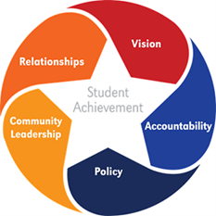
As schools move towards digital learning environments, it is necessary to foster support beyond district and school leaders to advance the transition. Local school board members, and those serving on the boards of education service agencies or on their state school boards association’s board of directors, play an important leadership role in modernizing educational settings. The local school board, whether elected or appointed, is the link between the school district and the community. The primary mission of the school board is to support student achievement. The National School Boards Association (NSBA) identifies the Key Work of School Boards necessary to ensure that all students achieve at high levels. These five core areas of responsibility for effective governance are: vision, accountability, policy, community leadership, and board/superintendent relationships. The following principles of collaborative leadership and community partnerships identify ways that school board members can connect policies and practices to support the movement towards digital learning. Although, the current state of digital innovation in schools varies widely across the country, these principles are based on the belief that all students have access to the digital tools and resources necessary to be prepared for college and/or career.
From NSBA’s Key Work of School Boards Guidebook, 2015

“We know what a good school board looks like. The impressive results are evident when a board of education makes student achievement the primary focus.”
- Ann Flynn, National School Boards Association

KEY CONCERNS FOR SCHOOL BOARD MEMBERS
This section highlights some of the key concerns that school board members hear from parents or other constituencies about digital learning. They include screen time, data privacy and security, the homework gap, collaborative leadership and community partnerships.

Screen Time

I’m concerned my child is spending too much time with electronic media.

Screen time may include watching television, movies, and videos; playing games; listening to music; using social media; reading; and/or browsing websites either as independent activities or via multi-tasking. Parents play an important role in helping school-age children balance media use with other healthy behaviors according to recent guidance from the American Academy of Pediatrics.

In addition, all screen time is not the same. Research highlighted in Tap, Click, Read from the Joan Ganz Cooney Center at Sesame Workshop identified how digital technologies can be used to improve, instead of impede, early literacy when parents are engaged. They have created resources that assist families to make the most of screen time.

Student Data Privacy
I am worried about who has access to my child’s information and how it might be used. What measures are in place to ensure that information is protected?

Those concerns fall into two distinct categories of privacy and security; first, the privacy policies that govern who is entitled to access information about a student and two, the technical security measures utilized by the district to minimize data breaches from outside attacks.

Federal laws, like the Family Educational Rights and Privacy Act (FERPA) provides parents with certain protections regarding their children's education records, and the Children's Online Privacy Protection Act (COPPA) protects the privacy of children under 13. The collection of data is essential to help teachers and school leaders meet the individual needs of students and/or identify trends within a school.

Districts face the same challenges as other agencies and businesses that are charged with protecting the data of both staff and students from outside attacks. Board members are encouraged to learn about their own district’s preventive measures to provide security and to encourage the proactive development of a crisis management plan should a data breech occur. Knowledge of that information can help ease concerns.

Learn more about student privacy and data security

Children's Online Privacy Protection Act (COPPA)

Data Quality Campaign

Data Security for Schools from NSBA’s Council of School Attorneys (COSA)

Family Educational Rights and Privacy Act (FERPA)

K-12 Privacy Toolkit for School Leaders from Consortium for School Networking (CoSN)
Privacy Technical Assistance Center

Homework Gap
What about the children in our district who don’t have internet access at home? How is our district addressing digital equity?

The term “homework gap” refers to the digital divide that exists between those students who have access to the Internet at home and those who do not. That reality is well documented through the Pew Research Center that reports 5 million households with school-age children do not have broadband access at home. Low-income households—especially Black and Hispanic households—make up a disproportionate share of those households. Some districts have actively partnered with internet providers in their communities to offer discounted service fees, others issue hot spots that students can take home, while others have adjusted school library hours to offer more access. School board members should be familiar with how digital equity is addressed in their own district.

Learn more about how school districts are addressing equity of access outside of school.

Broadband Imperative II

Digital Equity Action Toolkit

Collaborative Leadership
How can school members support district and school leaders in the transition to digital learning?

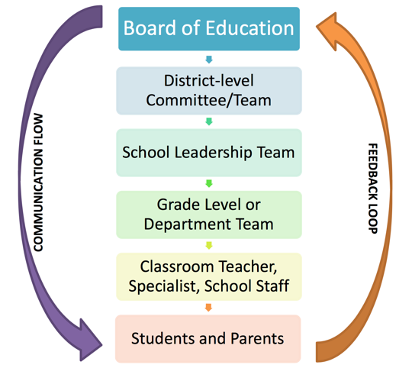
The support of local and regional school board members is essential for superintendents and school leaders to effectively implement digital learning. NSBA identifies the core skills that effective school boards need to ensure student achievement, one of which is the relationship between the school boards and the superintendent. NSBA asserts that both the school board and the superintendent have essential leadership roles that are interconnected but different. Through collaborative leadership, school boards have an excellent opportunity to support the transition to digital learning environments. Board policies and budget decisions can greatly impact learning opportunities--from decisions to providing Wi-Fi campus-wide or on buses to identifying resources for a district provided device program. NSBA addresses effective collaboration between stakeholders in their College and Career Toolkit, as well as, On the Same Page 2.0, a guide for the design and implementation of a teaching and learning environment. The guide is intended to spark conversation and suggestions among stakeholders and emphasizes the importance of information flow for continuous improvement and ownership by all stakeholders. Learn more about the school board and superintendent relationship.

On the Same Page 2.0, 2015

Community Partnerships
What steps can board members take to engage the community and create awareness around the benefits of learning in a digital environment?

School board members are community leaders, working to develop strong relationships with other community members to ensure that all stakeholders are vested in successful schools. Through advocacy and strategic community engagement, school boards can generate public and parental support for digital learning. As districts and schools transition to digital, school board members can be effective allies to increase community awareness about the successful impact digital learning can have on student achievement and college and career readiness. School board members can meet and work with local business leaders to:
- Learn about what workforce skills they need
- Provide information about how technology based learning opportunities can help support these workforce goals
- Connect with local area businesses on purchasing and funding options
- Gain insight from industry experts

“Effective school boards recognize the impact of schools on the community”
- National School Boards Association

TRANSFORMING DIGITAL LEARNING

College and Career-Ready Standards at William Penn High School, Delaware. In this short video, William Penn High School, Delaware prepares students for the workplace by implementing college and career ready standards. Students collaborate and use digital tools and applications to enhance their learning experiences.

School Board Members Support College and Career-Ready Standards. This video shows students using digital tools and applications to prepare for college and a career. School board members discuss the positive impacts of adopting college and career ready standards to better prepare students for the future.

COMMUNICATION PACKET (In development)
The communication packet includes customizable templates. Partners can add logos,
examples or other resources to help engage stakeholders and support this topic. Users are encouraged to leverage these resources to support your work in engaging school board member by providing them with the resources needed to create an ecosystem of support and learning inside and outside of school walls.
- Newsletter/website snapshot
- Presentation slides to support conversations with stakeholders
- Social media promotion examples
- Press outreach
- Outreach email

For more information about learning in the digital age, please visit XXXX (website).

