PARENT/CARE PROVIDER COMMUNICATION TOOLKIT
This toolkit describes the parent/care provider role to support learning in the digital age to help ensure students are college and career ready. As schools move towards digital learning environments, it is necessary to foster parental support to advance the transition. District and school leaders need to educate parents on the benefits of digital learning to support personalized student learning, while addressing some of the parental concerns around digital citizenship, data privacy and security and the homework gap. National parent organizations may want to share this toolkit with members to explain the importance of moving towards digital learning and addressing some of the parental concerns as a district or school implements digital learning. This toolkit includes a communications packet with sample documents that are customizable for parent organizations and districts and schools to share with parents/care providers.

LEARNING IN THE DIGITAL AGE
Technology is an essential component of learning today. With digital applications, tools and resources, students can create content, interact with experts, collaborate with peers and participate in simulation activities. Personalized experiences put students at the center of learning and empowers students to take control of their own learning through flexibility and choice. The Every Student Succeeds Act (ESSA) acknowledges technology’s role in revolutionizing learning and includes definitions for digital learning and blended learning, and references technology throughout the legislation. The Non-Regulatory Guidance
Student Support and Academic Enrichment Grants publication provides an overview of activities LEAs may consider as they prepare for implementation of the effective use of technology (ESEA Section 4109). Specific activities include: supporting high-quality professional development for educators, school leaders, and administrators to personalize learning and improve academic achievement; building technological capacity and infrastructure; carrying out innovative blended learning projects; providing students in rural, remote, and underserved areas with the resources to benefit from high-quality digital learning opportunities; and delivering specialized or rigorous academic courses and curricula using technology, including digital learning technologies. Similarly, the National Education Technology Plan (NETP) calls for a “revolutionary transformation rather than evolutionary tinkering” in education and recognizes that we must leverage technology to provide engaging and powerful learning experiences for all students. Technology offers all students – urban, rural, low-income, ESL, special needs, high achieving – the opportunity to engage in dynamic learning activities. Education leaders at the federal, state, and local level have the opportunity to provide leadership to ensure that all students have personalized, engaging learning experiences.

ROLE TO SUPPORT LEARNING IN THE DIGITAL AGE
As schools move towards digital learning environments, it is necessary to foster support beyond district and school leaders to advance the transition. Parent organizations and parents/care providers play an important role in modernizing learning in the digital age. District and school leaders need to work to educate parent on the benefits of digital learning to support personalized student learning.

KEY AREAS FOR PARENTS/CARE PROVIDERS
This section highlights some of the key areas of concern that parents/care providers might express about learning in the digital age. They include the use of digital instructional materials, digital citizenship, student data privacy and security, and the homework gap.

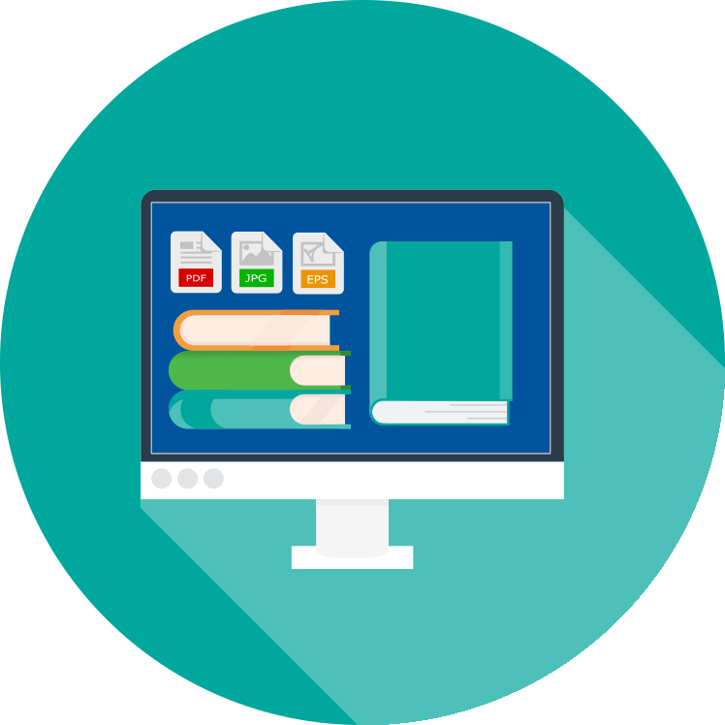
Instructional Materials
I don’t know what online resources to choose to help my children with homework. When I search the internet, there are so many choices.

Districts and schools will often have a list of vetted or approved digital tools and parents can seek school and teacher input when looking for supplemental tools and resources for their children. To find the best digital learning tools, parents should consider several factors including intended learning goals, alignment with child development, how integrated the learning elements are within the experience; how engaging the activities are, and how much kids can transfer what they learn to the real world. Parents should look for digital tools that include third-party research that proves efficacy. It is important for parents to understand that the active use of technology enables learning through creation, production and problem solving. Apps that mimic worksheets or flashcards are passive uses of technology that aren’t the best choices for learning. Instead, immersive experiences that match the needs of child development are recommended.

Learn more about choosing digital applications and resources

National Repositories

Common Sense Media: Parental Guide for Choosing Apps

State Vetted Digital Resources Repositories

Vetted Apps for Students by Grade Level

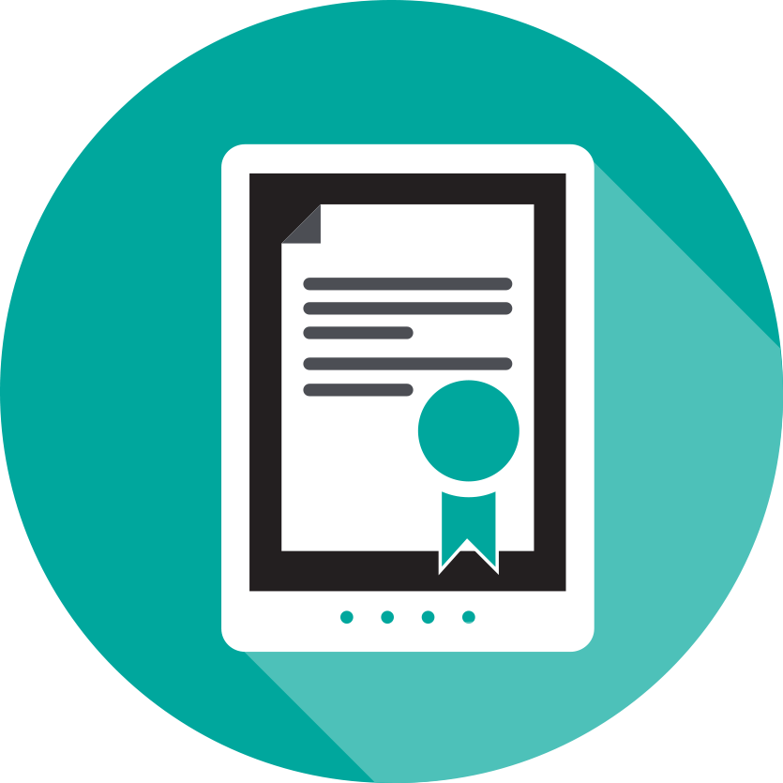

Digital Citizenship
How do I know that my child knows how to use the internet and digital resources responsibly? What resources are available for parents?

Students can learn how to use technology through a positive school culture that supports the safe and responsible use of digital tools and resources. Teachers, librarians and counselors are a good resource for students to learn about digital citizenship and how to navigate issues of cyberbullying, internet safety, digital footprint and other digital concerns.

Learn more about digital citizenship

Common Sense Education Cyberbullying and Digital Footprint

U.S Department of Health and Human Services Cyberbullying

Family Online Safety Institute: How to be a Good Digital Parent Toolkit

Safe and Secure Online

Homework Gap
My child requires access to the internet outside of school. Our internet is slow and unreliable. What can we do?

The “homework gap” – the gap between students whose internet connections at home are slow or non-existent—and those who have consistent home connections with adequate speed for learning activities in a safe environment is an increasingly important issue for districts, schools, students and parents. Some districts have actively partnered with internet providers in their communities to offer discounted service fees, others issue hot spots that students can take home, while others have adjusted school library hours to offer more access. Public libraries are another option for helping to address the “homework gap”. Many libraries offer access to free wireless internet, computers and devices, and digital resources. The FCC’s Lifeline program is another option for low-income families to acquire discounted broadband service at home.
2/3 of students say that it is important for them to have safe and consistent access to the internet when they are outside of school for them to be successful in school.
- Speak Up Survey 2015

Learn more about how you and your school/district can address the homework gap

Promoting Equity through Family-School Partnerships

FCC Lifeline Program
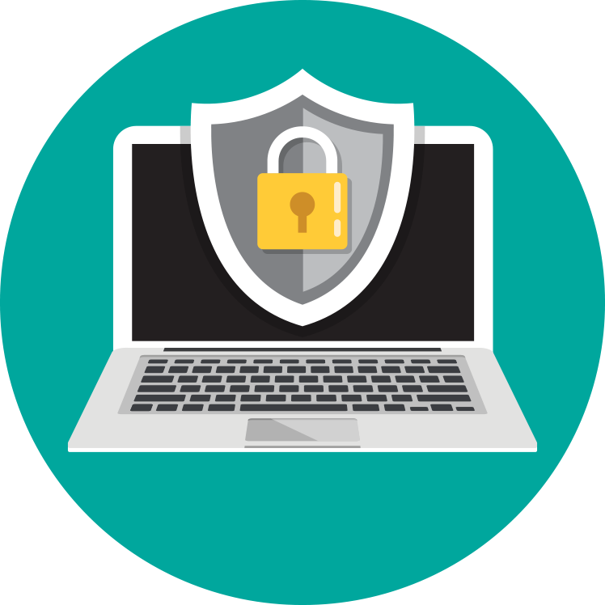

Student Data Privacy
I am worried about who has access to my child’s information and how it might be used. What measures are in place to ensure information is protected?

Parents are often concerned about data privacy. Districts and schools often collect real-time data to provide personalized instruction and/or to identify trends within a school or district. Data privacy policies govern who is entitled to access information about a student and data security--the technical security measures utilized by the district to minimize data breaches from outside attacks. Parents should become familiar with federal laws, such as the Family Educational Rights and Privacy Act (FERPA) that provides parents with certain protections regarding their children's education records, and the Children's Online Privacy Protection Act (COPPA) which protects the privacy of children under 13.

Learn more about student data and privacy
Privacy Technical Assistance Center

Family Educational Rights and Privacy Act (FERPA)

Children's Online Privacy Protection Act (COPPA)

TRANSFORMING DIGITAL LEARNING

Good Digital Parenting. In this short video by the Family Online Safety Institute, teens help parents to understand, discuss and encourage the use online privacy settings for their children. https://youtu.be/zBNOb_PvLrw

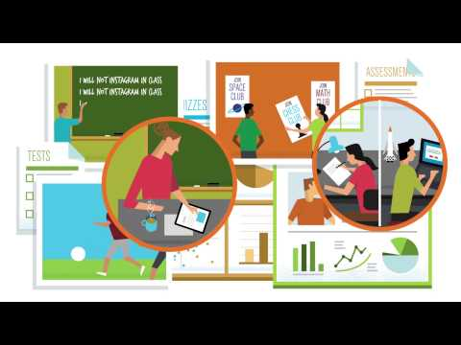

What is Student Data? In this short video, learn more about how student data can empower parents, students, educators and policymakers. There are many types of data that support student learning. The video shows the types of data that can come together—under requirements like privacy and security—to form a full picture of student learning. https://www.youtube.com/watch?v=3g4ifVVf-RI

What Parents Need to Know About Their Student’s Data. In this short video by the US Department of Education Privacy Technical Assistance Center, parents learn more about why schools/districts collect and use data. The video provides tips for parents to learn more about what data their district is collecting and how they are protecting data. https://youtu.be/Xa0cSA57fIQ

COMMUNICATION PACKET
The communication packet includes customizable templates. Partners can add logos,
examples or other resources to help engage stakeholders and support this topic. Users are encouraged to leverage these resources to support your work in engaging parents by providing them with the resources needed to create an ecosystem of support and learning inside and outside of school walls.
- Newsletter/website snapshot
- Presentation slides to support conversations with stakeholders
- Social media promotion examples
- Press outreach
- Outreach email

