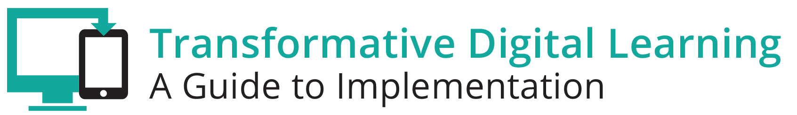

Teachers Communication Packet
This communication packet includes sample customizable templates where you can add your logos and modify the content to meet your needs. It includes
- Newsletter/website snapshot
- Presentation slides
- Sample tweets
- Press outreach
- Email outreach

Newsletter/Website Snapshot
Teachers are the linchpin to implementing effective learning environments. Many teacher leaders have embraced technology tools and resources in the classroom similar to how they have adopted these tools in their personal lives and professional learning opportunities. These teachers recognize that leveraging technology tools and resources is essential for all careers from clerks to mechanics to artists to engineers to physicians – all professions are expected to understand and implement technology tools and resources. As teachers transition to digital learning, there is a need to re-establish classroom routines, change lesson planning and student activities and shift expectations to best meet the needs of all students. Find out more about learning in the digital age and the role of teachers by accessing the Transforming Digital Learning Teacher toolkit.

Presentation Slides
http://www.setda.org/dlearning/wp-content/uploads/sites/15/2018/03/Teachers-Presentation.pptx

Sample Tweets

Learn more about the role of teachers in the digital age [website tiny url] #edtech

Access the Transforming Digital Learning Teacher Toolkit [website tiny url] #edtech
#[your organization]

How can I help teachers effectively utilize digital instructional materials? [website tiny url] #edtech #[your organization]

Press

Dear [Press]

We are pleased to share with you the Transforming Digital Learning Teacher toolkit. Teachers are at the center of student learning and maximizing digital learning opportunities is only possible when teachers have the support and access to the tools necessary to transform learning experiences in the digital age. Many teacher leaders have embraced technology tools and resources in the classroom similar to how they have adopted these tools in their personal lives and professional learning opportunities. These teachers recognize that leveraging technology tools and resources is essential for all careers from clerks to mechanics to artists to engineers to physicians – all professions are expected to understand and implement technology tools and resources. As teachers transition to digital learning, there is a need to re-establish classroom routines, change lesson planning and student activities and shift expectations to best meet the needs of all students. Find out more about learning in the digital age and the role of teachers by accessing the Teacher toolkit.

Ultimately, it’s not about the technology at all. It’s about changing the way learning and teaching take place. - ISTE

Thank you,

[Teacher organization/association}

Email

Dear [Teacher]

We are pleased to share with you the Transforming Digital Learning Teacher toolkit. As you know, teachers are at the center of student learning and maximizing digital learning opportunities is only possible when teachers have the support and access to the tools necessary to transform learning experiences in the digital age. In this toolkit, you will learn more about learning in the digital age and the role of teachers. As you explore more about professional learning, instructional materials and digital citizenship--key areas of interest for teachers--you will find information, tips and resources in each of these key areas.

We encourage you to share this valuable resource with your colleagues. You can learn more about Transforming Digital Learning on the website.

Sincerely,

[Teacher organization/association]

