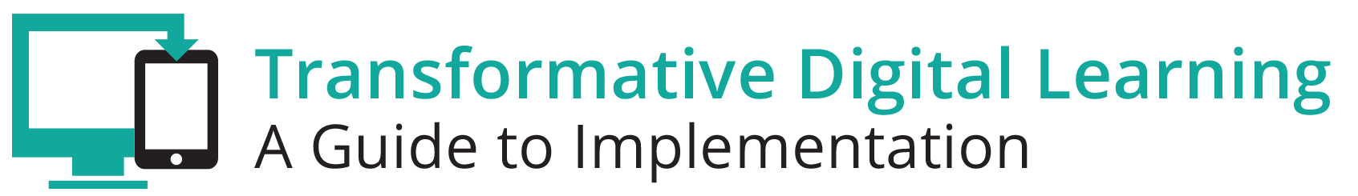

Teacher Preparation Communication Packet
This communication packet includes sample customizable templates where you can add your logos and modify the content to meet your needs. It includes
- Newsletter/website snapshot
- Presentation slides
- Sample tweets
- Press outreach
- Email outreach

Newsletter/Website Snapshot
As schools move towards digital learning environments, it is necessary to support educator preparation programs (EPP) via both institutions of higher education programs and non-traditional preparation programs in the transition. Teachers that are best prepared for digital learning environments are immersed with digital tools and resources during their own educational experiences and understand the value of digital tools and resources for student learning. Find out more about learning in the digital age and the role of both faculty and preservice teachers that are part of EPP by accessing the Transforming Digital Learning Teacher Prep toolkit. The toolkit highlights some of the key areas of interest for EPPs, including professional learning and best practices.

Presentation Slides
http://www.setda.org/dlearning/wp-content/uploads/sites/15/2018/03/Teacher-Prep-Presentation.pptx

Sample Tweets
Learn more about the role of educator preparation programs in the digital age [website tiny url] #edtech

Access the Transforming Digital Learning Teacher Prep toolkit [website tiny url] #edtech
#[your organization]

Learn how to bridge the gap between teacher preparation programs and school systems [website tiny url] #digitalage #[your organization]

Tips for EPP faculty in the digital age – Teacher Prep toolkit @OfficeofEdTech #edtech

Press

Dear [Press]

We are pleased to share with you the Transforming Digital Learning Teacher Prep toolkit. As schools move towards digital learning environments, it is necessary to ensure that preservice teachers gain the knowledge and skills required for teachers working in digital age classrooms. Teachers that are best prepared for digital learning environments are immersed with digital tools and resources during their own educational experiences and understand the value of digital tools and resources for student learning. Find out more about learning in the digital age and the role of both faculty and preservice teachers that are part of educator preparation programs (EPP) via both institutions of higher education programs and non-traditional preparation programs by accessing the Transforming Digital Learning Teacher Prep toolkit. The toolkit highlights some of the key areas of interest for EPPs, including professional learning and best practices. We encourage you to find out more about learning in the digital age by accessing the Teacher Prep toolkit.

“Providers ensure that candidates model and apply technology standards as they design, implement and assess learning experiences to engage students and improve learning; and enrich professional practice.” - Council for Accreditation of Educator Preparation

Thank you,

[Teacher Prep/Faculty Organization/Association]

Email

Dear [Preservice teacher/faculty]

We are pleased to share with you the Transforming Digital Learning Teacher Prep toolkit. As schools move towards digital learning environments, it is necessary to ensure that preservice teachers gain the knowledge and skills required for teachers working in digital age classrooms. Teachers that are best prepared for digital learning environments are immersed with digital tools and resources during their own educational experiences and understand the value of digital tools and resources for student learning. Find out more about learning in the digital age and the role of both faculty and preservice teachers that are part of educator preparation programs (EPP) via both institutions of higher education programs and non-traditional preparation programs by accessing the Transforming Digital Learning Teacher Prep toolkit. As you explore more about professional learning and best practices--key areas of interest for faculty and preservice teachers--you will find information, tips and resources in each of these key areas.

We encourage you to share this valuable resource with your colleagues. You can learn more about Transforming Digital Learning on the website.

Sincerely,

[Teacher Prep/Faculty Organization/Association]

