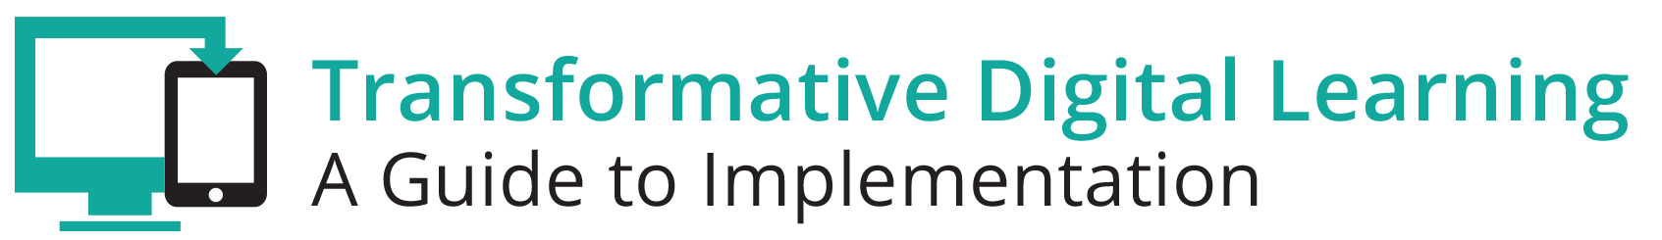

Student Communication Packet
This communication packet includes sample customizable templates where you can add your logos and modify the content to meet your needs. It includes
- Newsletter/website snapshot
- Presentation slides
- Sample tweets
- Press outreach
- Email outreach

Newsletter/Website Snapshot
Effective digital learning environments are dependent upon successful student learning and achievement. Many students have embraced technology tools and resources in their personal lives—whether it’s engaging in social media, self-directed learning (outside of class assignments), listening to music, gaming, or video chatting with friends. Current business and workforce requirements demand the use of technology tools and resources from clerks to mechanics to artist to engineers to physicians. Many students see technology as a gateway to personalizing and self-blending learning around areas of interest that are academic or for career preparation purposes. Find out more about learning in the digital age by accessing the Transforming Digital Learning Student toolkit. Educators are encouraged to share this toolkit with students to inform them about the benefits of a digital learning environment, as well as some areas of concern.

Presentation Slides
http://www.setda.org/dlearning/wp-content/uploads/sites/15/2018/03/Students-Presentation.pptx

Sample Tweets

Learn more about the role of students in the digital age [website tiny url] #edtech

Access the Transforming Digital Learning Student toolkit [website tiny url] #edtech
#[your organization]

Student video promotes awareness about programs that provide internet access at home

Learn more about data privacy in the Student toolkit [website tiny url] #edtech #[your . #Lifeline

Press

Dear [Press]

We are pleased to share with you the Transforming Digital Learning Student toolkit. Effective digital learning environments are dependent upon successful student learning and achievement. Many students have embraced technology tools and resources in their personal lives—whether it’s engaging in social media, self-directed learning (outside of class assignments), listening to music, gaming, or video chatting with friends. Current business and workforce requirements demand the use of technology tools and resources from clerks to mechanics to artist to engineers to physicians. Many students see technology as a gateway to personalizing and self-blending learning around areas of interest that are academic or for career preparation purposes. Find out more about learning in the digital age by accessing the Transforming Digital Learning Student toolkit.

2/3 of students say that it is important for them to have safe and consistent access to the internet when they are outside of school for them to be successful in school.
- Speak Up Survey 2015

Thank you,

[Student organization/association}

Email

Dear [Student]

As you may know, effective digital learning environments are dependent upon successful student learning and achievement. Many students have embraced technology tools and resources in their personal lives—whether it’s engaging in social media, self-directed learning (outside of class assignments), listening to music, gaming, or video chatting with friends. Current business and workforce requirements demand the use of technology tools and resources from clerks to mechanics to artist to engineers to physicians. Additionally, many students see technology as a gateway to personalizing and self-blending learning around areas of interest that are academic or for career preparation purposes. Find out more about learning in the digital age by accessing the Transforming Digital Learning Student toolkit. As you explore this toolkit, you will find information, tips and resources in each of these key areas.

Sincerely,

[Student organization/association]

