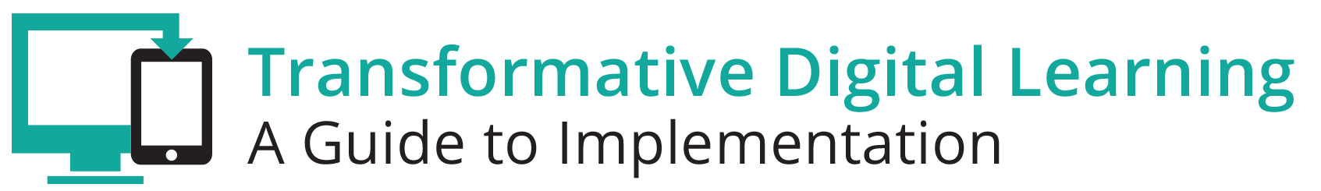

School Board Communication Packet
This communication packet includes sample customizable templates where you can add your logos and modify the content to meet your needs. It includes
- Newsletter/website snapshot
- Presentation slides
- Sample tweets
- Press outreach
- Email outreach

Newsletter/Website Snapshot
As schools move towards digital learning environments, it is necessary to foster support beyond district and school leaders to advance the transition. Local school board members, and those serving on the boards of education service agencies or on their state school boards association’s board of directors, play an important leadership role in modernizing educational settings. The local school board, whether elected or appointed, is the link between the school district and the community. Find out more about learning in the digital age and the role of the school board and school board members by accessing the Transforming Digital Learning School Board toolkit. The toolkit highlights some of the key areas of interest that school members might encounter during the transition to learning in the digital age--screen time, data privacy and security, and the homework gap.

Presentation Slides
http://www.setda.org/dlearning/wp-content/uploads/sites/15/2018/03/School-Board-Presentation.pptx

Sample Tweets
Learn more about the role of school board members in the digital age [website tiny url] #edtech

Access the Transforming Digital Learning School Board Member toolkit [website tiny url] #edtech #[your organization]

[website tiny url] #edtech #[your organization]

How is your district addressing the homework gap? Check out the Transforming Digital Learning School Board toolkit #edtech #digitalage

Press

Dear [Press]

We are pleased to share with you the Transforming Digital Learning School Board toolkit.
As schools move towards digital learning environments, it is necessary to foster support beyond district and school leaders to advance the transition. Local school board members, and those serving on the boards of education service agencies or on their state school boards association’s board of directors, play an important leadership role in modernizing educational settings. The local school board, whether elected or appointed, is the link between the school district and the community. We encourage you to find out more about learning in the digital age and the role of school board members by accessing the School Board toolkit. The toolkit highlights some of the key areas of interest that school members might encounter during the transition to learning in the digital age--screen time, data privacy and security, and the homework gap.

“Effective school boards recognize the impact of schools on the community”
- National School Boards Association

Thank you,

[School board member association}

Email

Dear [School board member]

We are pleased to share with you the Transforming Digital Learning toolkit. As you know, as schools move towards digital learning environments, it is necessary to foster support beyond district and school leaders to advance the transition. Local school board members, and those serving on the boards of education service agencies or on their state school boards association’s board of directors, play an important leadership role in modernizing educational settings. The local school board, whether elected or appointed, is the link between the school district and the community. Learn more about learning in the digital age and the role of school board members by accessing the School Board toolkit. As you explore more about screen time, data privacy and security and the homework gap--key areas of interest for school board members--you will find information, tips and resources in each of these key areas. We encourage you to share this valuable resource with your colleagues. You can learn more about Transforming Digital Learning on the website.

Sincerely,

[School Board association]

