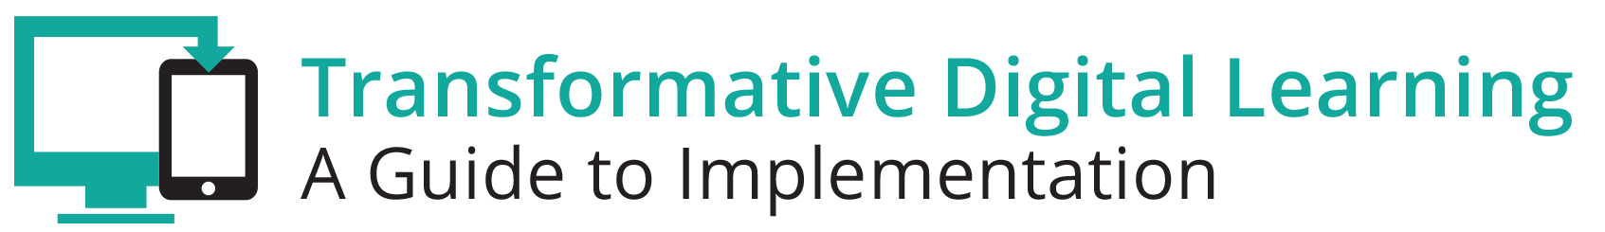

Facilitator Guide – Professional Learning

What is in this Guide?
This guide provides facilitators with the information they need to conduct a workshop around the essential components of state and/or district digital learning plans. It is our assumption that the facilitator will have at least a basic knowledge about learning in the digital age. Ideally, the facilitator should understand the basic components of a digital learning plan.
This guide provides facilitators with step by step activities, with suggested times for each activity, as well as narrative content and resources to support the topic. This guide is accompanied by a presentation slide deck for use during the workshop. It also includes a link to the logistics spreadsheet to help facilitators plan the workshop. Logistics include recommendations for audio visual, catering, registration and outreach.
This facilitator guide can be used in its current format or it is easily customizable to meet your needs. The guide is organized as follows:
- Purpose of the workshop
- Objectives for participants
- Key sections with suggested times
- Resources

Purpose
The goal of this session is to provide participants, typically school and district leaders, with the opportunity to gain knowledge around strategies for implementing professional learning in your school/district.

Objectives
- Learn more about professional learning strategies.
- Complete the professional learning readiness assessment.
- Discuss the results of the assessment with your peers and strategize ways to improve professional learning in your school/district.
- Learn best practices from your colleagues.
- Develop and maintain relationships with other district and state leaders.

Session Overview (90 minutes)
- Welcome and Introductions (5-10 minutes)
- Background (10-15 minutes)
- Professional Learning Readiness (10-15 minutes)
- Professional Learning Activity (25-30 minutes)
- Exemplar Rapid Fire Presentations (15-20 minutes)
- Reflection and Wrap Up (5-10 minutes)

**Please note – the timing of activities requires a rapid paced session. Each facilitator will need to consider their audience (as related both to background knowledge and size) as well as future opportunities for professional learning opportunities around the topic and then choose the activities and time commitment for each.

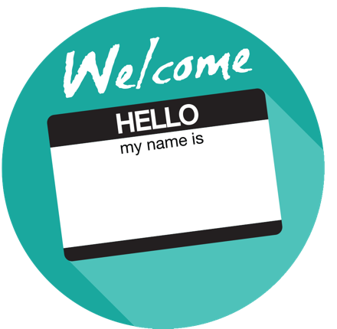

Welcome and Introductions (5-10 minutes)
Facilitator Note: Introduce yourself, review the agenda and logistics for the session. Introduce the welcome activity. This activity will help the facilitator better understand the audience. If you have a large group, ask the participants to complete this via individual tables vs whole group. You can also choose an activity from the Activity Toolbox.

My Favorite Things
Participants will introduce themselves and then share their favorite tool or app they have used for their own professional learning and why it is effective.

Background (10-15 minutes)
Facilitator Note: Share some general background information on how technology enhances professional learning through learning communities and how schools can support teachers by providing professional learning opportunities. The facilitator will also share the featured video or select one of their own.

Overview
Technology offers the opportunity for teachers to become more collaborative and extend learning beyond the classroom. Educators can create learning communities composed of students; fellow educators in schools, museums, libraries, and after-school programs; experts in various disciplines around the world; members of community organizations; and families. This enhanced collaboration, enabled by technology offers access to instructional materials as well as the resources and tools to create, manage, and assess their quality and usefulness. To enact this vision, schools need to support teachers in accessing needed technology and in learning how to use it effectively. Educators need continuous, just-in-time support that includes professional development, mentors, and informal collaborations.

Educators will be supported by technology that connects them to people, data, content, resources, expertise, and learning experiences that can empower and inspire them to provide more effective teaching for all learners. (NETP 2017 Goal for Teaching with Technology).

Professional Learning Plan
A district professional learning plan provides the opportunity to establish short- and long-term professional learning goals for instruction, to articulate how professional learning will take place, and delineates desired outcomes. Approaching professional learning planning comprehensively allows districts to achieve efficiencies and alignment and reduce redundancy across the schools. Districts with successful professional learning initiatives typically align goals, activities and outcomes across their departments, schools, and district. With this approach, planning for digital learning becomes one facet of broader professional learning planning efforts.

Facilitator Note: The facilitator describes PLAYDATE, where educators explore and learn more about how to use technology in the classroom. Next, the facilitator shows the featured video. Choose whole group, table or partner discussion depending on timing and size of group to answer discussion questions.

Overview

PLAYDATE - People Learning and Asking "Y": Digital Age Teacher Exploration
Educators come together and sit in a room for a few hours and just play and learn about apps, programs and tools with one another. There are no presenters in the room, no experts and no agenda.

Is PLAYDATE right for you?
https://youtu.be/cDnrsC-Ioug

Discussion Questions
- Why might learning a tool or an app through play/tinkering rather than demonstration be an effective way for educators to learn?
- What is exciting about having a “playdate” at your school or district?
- What are the challenges?

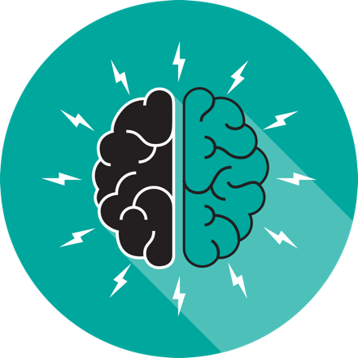
Professional Learning Readiness Activity (10-15 minutes)
Facilitator Note: The facilitator should have printed copies of the self-assessment tool or ask participants to record their answers on a blank piece of paper. Each participant will complete the self-assessment tool for their school or district. After completion, ask the participants to total the scores in each section. These scores will be used later in the workshop.

Professional Learning Readiness Self-Assessment Tool
This tool helps districts assess their capacity for effective, comprehensive professional learning. Comprehensive professional learning includes face-to-face and virtual learning experiences, formal and informal learning opportunities.

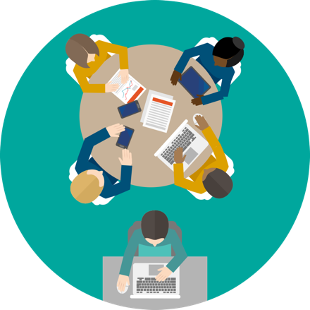

Professional Learning Activity (25-30 minutes)
Facilitator Note: The facilitator introduces the OET Professional Learning Toolkit and briefly describes the 5 steps in the process. The facilitator asks participants to set up an online collaborative document to record their answers to the discussion questions. All tables should have links to the docs for the other tables for whole group sharing.

The Office of Education Technology, Empowering Educators through Professional Learning toolkit provides leaders with a multi-step decision-making process, practical tools, and numerous examples for setting a trajectory of positive change, moving assertively toward achievement of student learning and improvement goals. You may choose to move linearly from one step to the next, or skip directly to a particular step. Key steps in the process are:
- Determine District Readiness
- Assess Current Professional Learning
- Refine Professional Learning
- Implement Professional Learning
- Measure Refined Professional Learning

Small Group (15-20 minutes)
At each table, participants should share their results and observations from the Professional Learning Readiness Self-Assessment completed earlier. Next, participants should answer the discussion questions using a collaborative online document.

Whole Group (10 minutes)
The facilitator will share the online collaborative documents from several tables and ask participants to add more suggestions or comments.

Discussion Questions
- Are you stronger in some sections of the self-assessment?
- Depending on the level of readiness of your district, what would it take to increase the level of readiness? Who needs to be involved in increasing the level of readiness?
- How could current professional learning in your school, district or state be personalized to meet the needs of teachers?
- What are some ways that your school/district can leverage digital tools to support your professional learning strategies?

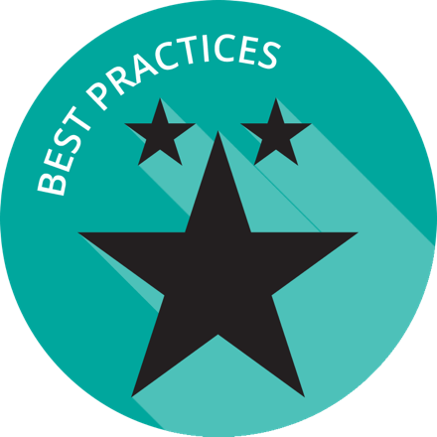

Exemplar Rapid Fire Presentations (15-20 minutes)
Facilitator Note: Ask two exemplar school/districts to share their background and experience in professional learning. The presentations should be 5-7 minutes and prepared in advance of the workshop. Additional information about presentations can be found in the Logistics resource.

Discussion Questions
- How is your school/district similar to the exemplar?
- Are there policies/practices shared that your school/district can implement within the next quarter?
- Share some of your professional learning opportunities with the group.

Reflection and Wrap Up (5 minutes)
Facilitator Note: Take a few moments to reflect on the session, share details about additional events related to the remainder of the day and engage the audience to take action when they return to their schools/districts. Use this activity or choose another one from the Activity Toolbox.

3+2+1 Activity
Participants should write the following on a piece of paper:
- 3 things you learned from today’s session
- 2 questions you still have
- 1 idea that stuck with you

Based on the reflection activity, identify the next steps for your state, district or school.

Wrap-Up
Facilitator Note: The facilitator wraps up the day and shares resources with participants. Sample language: “This is only the first step of many steps in supporting teachers and students for learning in the digital age. I encourage you to follow up on our reflection activity during the next few weeks and continue to collaborate with your peers. Think about what tools and resources you can use to maintain relationships and encourage collaboration, as well as identify opportunities for on-going professional learning and workshops.

Resources
The US Department of Education does not endorse any resources; instead they are provided to assist the facilitator in preparing for the workshop. The facilitator can also share these resources with participants to support on-going professional learning and school/district planning after the workshop. For example, some districts have used the NETP for on-going book studies throughout the school year to support the development and refinement of technology initiatives.

US Department of Education Resources

Building Technology Infrastructure for Learning

Every Student Succeeds Act (ESSA)

National Education Technology Plan (NETP)

Stories of Ed Tech Innovation

Facilitator Guide Resources

