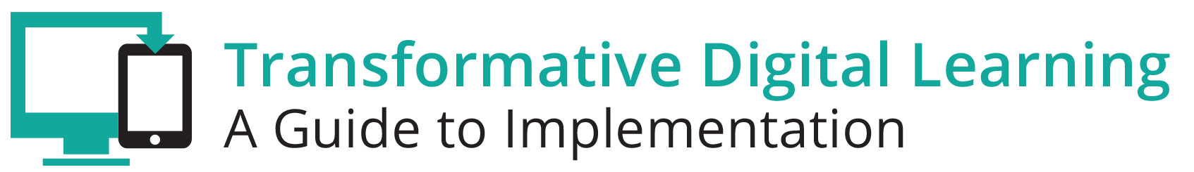

Facilitator Guide – Interoperability

What is in this Guide?
This guide provides facilitators with the information they need to conduct a workshop around the essential components of state and/or district digital learning plans. It is our assumption that the facilitator will have at least a basic knowledge about learning in the digital age. Ideally, the facilitator should understand the basic components of a digital learning plan.
This guide provides facilitators with step by step activities, with suggested times for each activity, as well as narrative content and resources to support the topic. This guide is accompanied by a presentation slide deck for use during the workshop. It also includes a link to the logistics spreadsheet to help facilitators plan the workshop. Logistics include recommendations for audio visual, catering, registration and outreach.
This facilitator guide can be used in its current format or it is easily customizable to meet your needs. The guide is organized as follows:
- Purpose of the workshop
- Objectives for participants
- Key sections with suggested times
- Resources

Purpose
The goal of this session is to provide participants (typically school and district leaders) with the opportunity to gain knowledge and resources to better understand interoperability standards and how to best address interoperability needs as current technology based education resources are reviewed and new resources are considered for purchase.

Objectives
- Understand interoperability needs
- Review national interoperability standards and tools
- Hear from exemplars on how to overcome challenges
- Interact with your peers to learn what tools they use
- Develop and maintain relationships with other district and state leaders

Session Overview (Total time: 90 minutes)
- Welcome and Introductions (10 minutes)
- Background (10 minutes)
- Exemplar Rapid Fire Presentations (15-20 minutes)
- Overview of Interoperability Standards and Tools (10 minutes)
- Brainstorming Activity for Interoperability Standards and Tools (5-10 minutes)
- Diagram It Activity (20-25 minutes)
- Policies (5-10 minutes)
- Reflection and Wrap Up (5 minutes)

**Please note – the timing of activities requires a rapid paced session. Each facilitator will need to consider their audience (as related both to background knowledge and size) as well as future opportunities for professional learning opportunities around the topic and then choose the activities and time commitment for each.

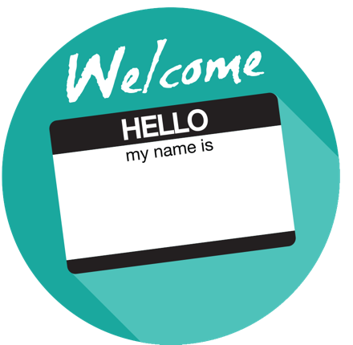
Welcome and Introductions (10 minutes)
Facilitator Note: Introduce yourself, review the agenda and logistics for the session. Introduce the welcome activity. This activity will also help the facilitator better understand the participants knowledge around interoperability. It will help the facilitator determine the depth of background information to share. If you have a large group have participants complete this via individual tables vs whole group. You can also choose an alternate activity from the Activity Toolbox.

Rank Yourself Activity
Ask the participants to introduce themselves by sharing their name, title, school/district and ask them to rank their knowledge regarding Interoperability. This activity can be completed via an online polling tool or in-person discussion via raising hands.

10 – I’m an expert and I am looking forward to sharing my expertise.
7 – I deal with this topic regularly however, I’m here to learn more from others.
5 – I know enough to be dangerous.
3 – I have a general idea of the topic however, this is an area of growth for me.
1 – I know this is an important topic so I am here to learn.

Background (10 minutes)
Facilitator Note: Facilitator provides an overview of the topic and shares a featured video.

Overview
While states, districts, and schools have long collected certain education data for accountability purposes, there is growing interest in leveraging data from digital learning tools, online services, educational apps, and other technologies. However, with all the data available to us through technology, school leaders and educators still lack the ability to easily transform that data to information to help guide decisions about instruction, school administration, and operations. Further, the systems we use to collect, manage, analyze, and report on that data are often disconnected and don’t work well together. Meanwhile, in other aspects of life beyond schools, such as shopping, healthcare, law enforcement, sports, entertainment and transportation, “smart” systems use data in extraordinarily sophisticated ways.

The goals for intelligent use of data in the education ecosystem are worthwhile. Aggregate data accumulated over years and from multiple sources can point the way to success for particular groups of students and/or for program evaluation. Likewise, information generated through digital learning and various applications can track a specific student’s progress over time and information can be made accessible to teachers and parents through real-time reporting tools.

Facilitator Note: Choose one of the featured videos or select one of your own videos. These videos can help level the playing field with the audience as this topic is often complicated and it may be helpful to ensure that everyone is on the same page. After the video, choose whole group, table or partner discussion depending on timing and size of group.

Digital Learning and Interoperability https://youtu.be/OgxrAtKzHn4
What is Interoperability? https://www.youtube.com/watch?v=qq5weRtCjdo

Discussion Questions
- How has your school/district addressed interoperability needs?
- Has your school/district addressed the legal provisions and disclosures about student records?
- How has your school/district addressed student and family access to a student’s personal data—such as test results or the need for special accommodations?
- How has your district/school addressed data storage?

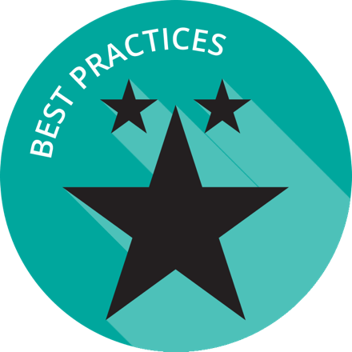

Exemplar Rapid Fire Presentations (15-20 minutes)
Facilitator Note: Ask two exemplar school/districts to share their background and experience. The presentations should be 5-7 minutes and prepared in advance of the workshop. Include at least one presentation related to interoperability either from a data expert from the state/district or non-profit that has tackled interoperability challenges and established minimum standards.

Discussion Questions
- How is your school/district similar to the exemplar?
- Are there practices shared that your school/district can implement in the short-term?
- How has your school/district tackled interoperability challenges?
- How much progress has your district made in establishing minimum standards?

Overview of Interoperability Standards and Tools (10 minutes)
Facilitator Note: Present the information below regarding interoperability standards, as well as the most common interoperability tools/resources. This section will help frame the participants thinking to prepare for the Diagram It activity. Acknowledge the massive undertaking for ensuring the need for the various standards and the need to coordinate data sets.

Overview
Interoperability standards allow data to flow between applications that are developed by different groups. Companies will make products align to certain standards to ensure compatibility with other products on the market. A commonly understood example of standards and compatibility is Bluetooth - a short range wireless standard that allows devices to communicate with one another. Phones can connect with wireless speakers via Bluetooth to play music or they can connect with the navigation system in a car to allow phone calls to be made by voice command. The phones, speakers, and car all built their products to align to the Bluetooth standard so that the devices would speak the same language in order to work together.

Similarly, standards for student information, assessment, digital content, and other needs have emerged for educational applications. When working with multiple products such as a learning management system, a student information system, and a learning object repository for example, educators should ensure that each product is aligned to the same interoperability standards so that the learning management system can easily access both the necessary student information such as class rosters and digital content, but also can allow grades to be entered and sent back to the student information system. If the applications are interoperable, educators will not have to enter grades in one system and then again in another, for example.

CoSN points out that there are gaps in the integration and interfaces among disparate applications and in a recent report highlights the most important, widely used, and emerging key areas of standards:
- Digital content
- Data connectivity
- Data integration
- Authentication, authorization and identity management
- Portals and portlets
- File sharing
- Network infrastructure
- Digital accessibility

Common Education Data Standards (CEDS): CEDS provides a common vocabulary and reference structure through a data dictionary and logical data model for information that needs to be shared across education organizations.

IMS Global Learning Consortium Specifications: IMS content, application, and data standards enable teachers to mix and match educational content and software from different sources into the same learning platforms.

P20W Education Standards Council (PESC): PESC consists of numerous standards for sharing specific types of education data, such as financial aid, transcript, and admissions information.

SIF Implementation Specification is a technical standard that is used by developers of education software to ease the transfer of data among applications in use by schools, districts and state education agencies.

Tools
The Future Ready Schools: Building Technology Infrastructure for Learning guide provides practical, actionable information intended to help district leaders (superintendents, principals, and teacher leaders) navigate the many decisions required to deliver cutting-edge connectivity to students. It presents a variety of options for district leaders to consider when making technology infrastructure decisions, recognizing that circumstances and context vary greatly from district to district.

Ed-Fi Alliance is a data model combined with a tool suite that streamlines the sharing of student data and also provides the dashboard elements for educators to improve the academic outcomes of students.

OneRoster® is a subset of Learning Information Services (LIS) and focus on a school’s needs to exchange roster information, grades, and related data.
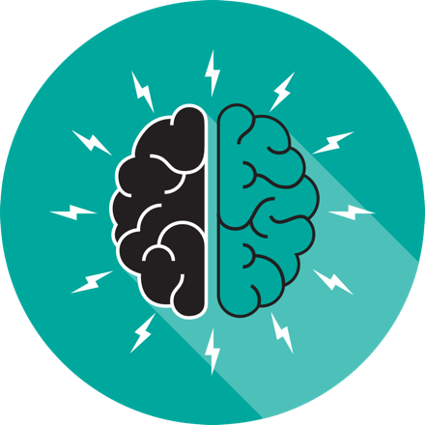

Brainstorming Activity (10 minutes)
Facilitator Note: Either via poster paper and markers or online collaboration tools, such as AnswerGarden, have the participants answer some or all of the following questions. Allow participants to respond the questions individually, then have individual tables discuss their responses. If time, have a couple of tables share with the whole group. Facilitator can also choose a brainstorming activity from the Activity Toolbox.

Discussion Questions
- Has your school or district adopted any of these standards? If yes, which ones?
- Are you familiar with these interoperability tools and resources?
- Are you using any of these tools? If so, can you provide feedback to the group?

Diagram It Activity (20-25 minutes)
Facilitator Note: The facilitator introduces the Diagram It activity or chooses another activity from the Activity Toolbox. The Diagram It activity has participants make a diagram of applications used by teachers and students and the data needs between those applications.

Diagram It!
Depending on time constraints, the facilitators can choose only the small group activity or both the small group and whole group activities.

Small Group (15-20 minutes)
The facilitator breaks the room into small groups. Each group will make a diagram of applications used by teachers and/or students. These can be actual applications used if the group is all from same school or system OR a diagram of an ideal set of applications. Then, between any two sets of applications, the group will list the data one application might need from the other (student name, grade level, class period, grades, assessments, etc). Some applications can share data out but cannot (or may not need to) receive data back from another application. The group could use one or two way arrows to show which way the data flows (or if describing an ideal state, which way should it flow).

For further discussion in the small group, if these applications are currently in use, determine if these applications currently share the data noted or does the data have to be entered or manually imported into one or both applications?

Whole Group (10-15 minutes)
After the individual group diagrams and discussions are completed, the facilitator brings the group together has each group share out their diagram. The first group will take the longest. The other groups do not need to repeat commonalities shared by prior groups, but can simply add on additional ideas.

Policies and Initiatives (5-10 minutes)
Facilitator Note: Engage the participants in a discussion regarding state and local policies related to interoperability.

Discussion Questions
- Are there local policies/practices that can be updated to support interoperability?
- Which stakeholders need to be involved in the conversations?

Reflection and Wrap Up (5-10 minutes)
Facilitator Note: Take a few moments to reflect on the session, share details about additional events related to the remainder of the day and engage the audience to take action when they return to their schools/districts. Use the following activity or choose one from the Activity Toolbox.

TAB
Ask the audience to share one “Ah-Ha” moment from the session discussions and share how they might implement that new information in their work.

Based on the reflection activity, identify the next steps for your state, district or school.

Wrap-Up
Facilitator Note: The facilitator wraps up the day and shares resources with participants. Sample language: “This is only the first step of many steps in supporting teachers and students for learning in the digital age. I encourage you to follow up on our reflection activity during the next few weeks and continue to collaborate with your peers. Think about what tools and resources you can use to maintain relationships and encourage collaboration, as well as identify opportunities for on-going professional learning and workshops.

Resources
The US Department of Education does not endorse any resources; instead they are provided to assist the facilitator in preparing for the workshop. The facilitator can also share these resources with participants to support on-going professional learning and school/district planning after the workshop. For example, some districts have used the NETP for on-going book studies throughout the school year to support the development and refinement of technology initiatives.

US Department of Education Resources
Building Technology Infrastructure for Learning
Every Student Succeeds Act (ESSA)
National Education Technology Plan (NETP)
Stories of Ed Tech Innovation

Facilitator Guide Resources
Blog on Defining Interoperability Within Your Digital Ecosystem
Blog on the Houston ISD IMS Interoperability Processes
CoSN’s Interoperability Primer: Working Together to Strategically Connect the K-12 Enterprise

