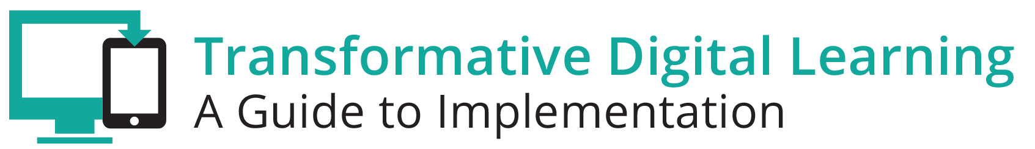

Facilitator Guide – Instructional Materials

What is in this Guide?
This guide provides facilitators with the information they need to conduct a professional learning session regarding the essential components of state and/or district digital learning plans. Ideally, the facilitator will have a basic understanding regarding learning in the digital age and some experience with the basic components of digital learning plans.

This guide includes step by step activities, with suggested times for each activity, as well as narrative content and resources to support the topic. This guide is accompanied by a presentation slide deck for use during the workshop. It also includes a link to the logistics spreadsheet to help facilitators plan the workshop. Logistics include recommendations for audio visual, catering, registration and outreach.

This facilitator guide can be used in its current format or it is easily customizable to meet your needs. The guide is organized as follows:
- Purpose of the workshop
- Objectives for participants
- Key sections with suggested times
- Resources

Purpose
The goal of this session is to provide participants, typically school and district leaders, with the opportunity to gain knowledge around the implementation of digital instructional materials.

Objectives
- Analyze definitions of quality instructional materials including the elements necessary for quality digital materials.
- Collaborate with peers.
- Determine best options for curating digital instructional materials.
- Learn more about how policies and practices can support the implementation of quality instructional materials for all learners.
Session Overview (Total time: 90 minutes)
- Welcome and Introductions (5-10 minutes)
- What are Quality Instructional Materials? (10 minutes)
- Quality Instructional Materials Activity (15 minutes)
- Beyond the Search Engine: Curation (15-20 minutes)
- Exemplar Rapid Fire Presentations (10-15 minutes)
- Policies (10-15 minutes)
- Reflection and Wrap-Up (5 minutes)

**Please note – the timing of activities requires a rapid paced session. Each facilitator will need to consider their audience (as related both to background knowledge and size) as well as future opportunities for professional learning opportunities around the topic and then choose the activities and time commitment for each.

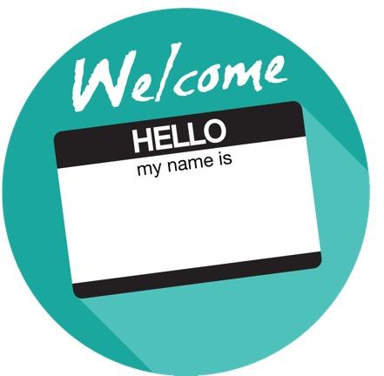
Welcome and Introductions (5-10 minutes)
Facilitator Note: Introduce yourself, review the agenda and logistics for the session. Introduce the welcome activity. This activity will help the participants think about the types of instructional materials that had an impact on their own learning. If you have a large group have participants complete this via individual tables vs whole group. You can also choose an activity from the Activity Toolbox. Content may be gathered via an online collaboration document, online polling tool or chart paper.

Ice-Breaker Activity
- Share your name, role and school/district.
- Think about your years as a student and instructor.
- Think of the one book, magazine series, novel, teachers guide, web-based tool or other instructional material that was most impactful for your learning experience. Was it the large spiral teacher’s guide, Mailbox Magazine, TeacherTube videos, your 2nd grade Reader?

What are Quality Instructional Materials? (10 minutes)
Facilitator Note: Discuss the active use of technology for teaching and learning and present definitions for quality instructional materials for student learning.

Overview
The NETP Digital Use Divide Infographic states that we must close the digital use divide and focus on the active use of technology to enable learning and teaching through creation, production and problem-solving. Media production; immersive simulations; and coding are active uses of digital tools. Definitions for digital instructional materials may vary somewhat from one professional organization to the next, yet, all agree that quality materials should be robust materials aligned to learning standards, accessible by all students, whether they are full course materials or supplemental materials, open or all rights reserved copyright.

SETDA
Quality instructional materials are content-rich materials aligned to standards that are fully accessible and free from bias. They support sound pedagogy and balanced assessment to help teachers understand and interpret student performance.

Quality Instructional Materials must be:
- Aligned to state, district, and building learning standards as measured by widely-accepted evaluation tools.
- Current, relevant, and accurate content that is user friendly, fully accessible for all learners, and free from bias.

Full-course, core instructional material should:
- Emphasize the key areas of focus within each course, addressing the progression of learning skills, and vertically articulating content with other courses to ensure coherence.
- Support differentiated learning behaviors and include resources for students who struggle and opportunities for students to be challenged.
- Include a balanced assessment strategy to help teachers understand and interpret student performance.
- Incorporate technology, where appropriate, that supports quality teaching and learning.

State Instructional Materials Review Association (SIMRA)
SIMRA identifies three criteria for the selection of instructional materials, regardless of format (print vs digital).
- Content – Aligned to core standards and objectives that lead to college and career readiness and is structured to ensure that all students meet grade-specific expectations as they develop literacy skills.
- Accessibility– Materials are free from bias in their portrayal of ethnic groups, gender, age, disabilities, cultures, religion, etc., and contain accommodations for multiple learning styles, students with exceptionalities, English Language Learners, and cultural differences. They are durable and of high quality in physical structure, and are designed to promote optimal learning experiences for all students.
- Pedagogical Design– Materials provide tools for a balanced approach to assessment including both formative and summative assessments in multiple formats not only to guide instruction but also to identify student mastery of content. Information is organized logically and presented clearly using multiple methods and modes for delivering instruction that motivate and increase literacy as students engage in high interest, authentic activities. Instructional design utilizes research-based instructional strategies, offers suggestions for appropriate scaffolding, emphasizes the importance of vocabulary acquisition, provides opportunities to engage in high interest, age-appropriate activities that mirror real-life situations, and make cross-curricular, global connections.

Additional Sample Definitions of Quality Instructional Materials: http://qualitycontent.setda.org/planning/#quality-materials

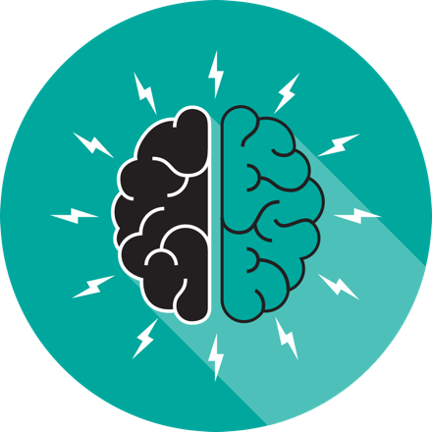

Quality Instructional Materials Activity (10-15 minutes)
Facilitator Note: Participants will analyze definitions of quality instructional materials including the elements necessary for quality digital materials. Introduce the Think-Pair-Share activity or choose another activity from the Activity Toolbox.

Think-Pair-Share Activity
- Think: Have participants think about their definition for quality instructional materials.
- Pair: Talk with a partner and discuss the elements of quality instructional materials.
- Share: Share an “aha moment” with your partner or whole group depending on the size of the group.

Beyond the Search Engine Curating Instructional Materials Activity (15-20 minutes)

Facilitator Note: The facilitator provides some background and introduces the beyond the search engine stickie collaboration note activity. Participants will learn from their peers about hosting and packaging digital instructional materials. The facilitator can use this activity or another activity from the Activities Toolbox.

After instructional materials are approved, states, districts and schools need to curate those vetted materials. When curating materials, educators can consider how these materials may help personalize learning for students and the ease of access for teachers to use these materials. Curation includes both hosting the digital instructional materials content and packing the content. Options include:

Hosting Content
- State digital repository
- District/school repository
- Vendor platform

Packaging the Content
- Easily accessible for teachers
- Useful to teachers
- Searchable by content area, standard, or grade

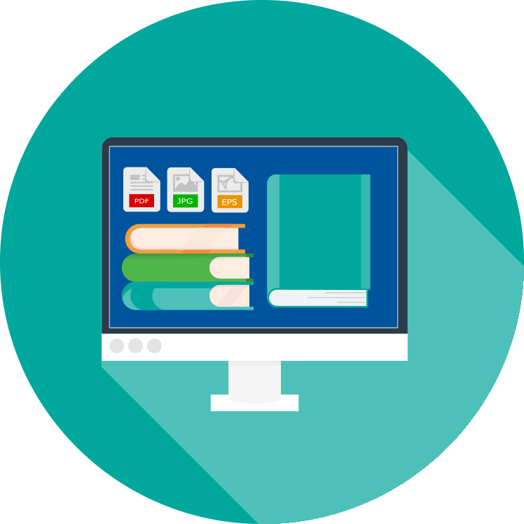

Independent (5 minutes)
Ask the participants to write down on a sticky note where their school/district/state hosts digital instructional materials (state repository, district content management system, school content management system). Also ask what platform they use. It’s okay if they don’t know.

Small Group Sharing (5 minutes)
The facilitator organizes all of the stickie notes into like groups. Ask the participants to move to like groups and discuss. The facilitator may choose to organize groups based on state repositories, district repositories, or school content management systems

Whole Group (5-10 minutes)
After the small groups finish sharing, the facilitator brings the group together for a whole group share out.

Discussion Questions
- What are the benefits of your current system?
- What are the areas of growth?
- What are your pain points/challenges?

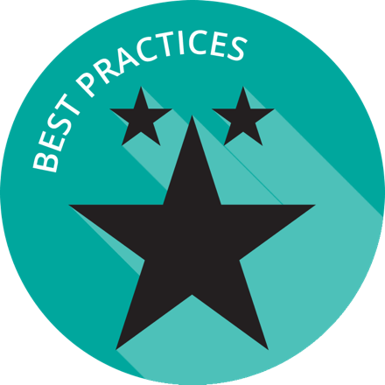

Exemplar Rapid Fire Presentations (10-15 minutes each)
Facilitator Note: Ask two exemplar school/districts to share their background and experience regarding quality instructional materials for learning. The presentations should be 5-7 minutes and prepared in advance of the workshop. Additional information about presentations can be found in the Logistics resource.

Discussion Questions
- How is your school/district similar to the exemplar?
- Are there practices shared that your school/district can implement right away?

Policies and Initiatives (5-10 minutes)
Facilitator Note: Encourage participant discussion around state and local policies for adoption, digital instructional materials and OER.

Overview
There are major shifts in state policy for the selection and implementation of instructional materials. More states have formal adoption policies for instructional materials and are requiring the implementation of digital instructional materials in the next five years. State and local leaders can build capacity by coordinating efforts and engaging in strategic planning. Learn more about state policies at http://qualitycontent.setda.org/planning/#statepolicesandpractices.

Discussion Questions
- What is your adoption policy for textbooks?
- What is your adoption policy for digital instructional materials?
- What are the requirements for digital instructional materials implementation?
- Do you have policies about OER?
- Are there local policies/practices that can be updated?
- Which stakeholders need to be involved in the conversations?
- What is your best option for selecting and curating digital instructional materials?

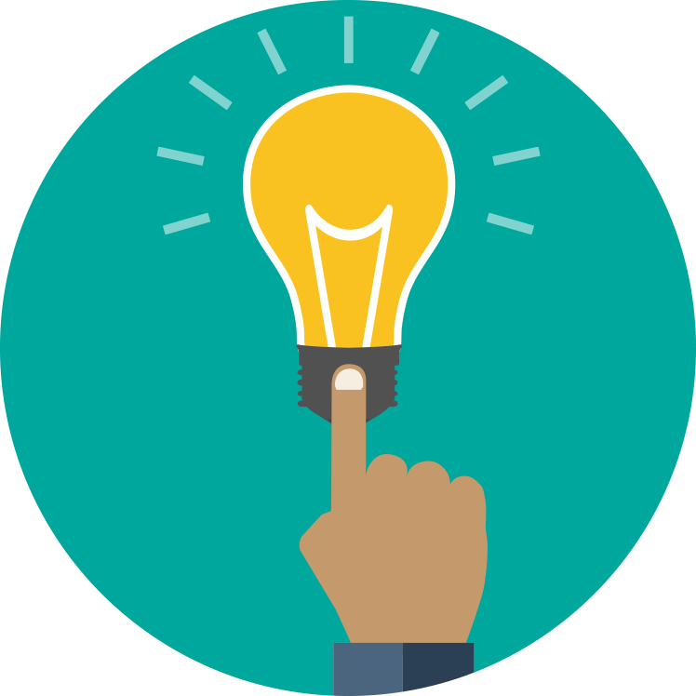

Reflection and Wrap Up (5 minutes)
Facilitator Note: Take a few moments to reflect on the session, share details about additional events related to the remainder of the day and engage the audience to take action when they return to their schools/districts. Use this activity or choose another one from the Activity Toolbox.

Audience Challenge
What can you do when you return to your position to help move the marker forward?
- Create a calendar appointment to remind yourself
- Mail a postcard to yourself
- Invite your colleagues to discuss the issues

Based on the reflection activity, identify the next steps for your state, district or school.

Wrap Up
Facilitator Note: The facilitator wraps up the day and shares resources with participants. Sample language: “This is only the first step of many steps in supporting teachers and students for learning in the digital age. I encourage you to follow up on our reflection activity during the next few weeks and continue to collaborate with your peers. Think about what tools and resources you can use to maintain relationships and encourage collaboration, as well as identify opportunities for on-going professional learning and workshops.

Resources
The US Department of Education does not endorse any resources; instead they are provided to assist the facilitator in preparing for the workshop. The facilitator can also share these resources with participants to support on-going professional learning and school/district planning after the workshop. For example, some districts have used the NETP for on-going book studies throughout the school year to support the development and refinement of technology initiatives.

US Department of Education Resources
Every Student Succeeds Act (ESSA)
National Education Technology Plan (NETP)

Additional Facilitator Resources
Navigating the Digital Shift,
Quality Instructional Materials Toolkit,
10 Common Criteria for Evaluation of Instructional Materials

Exemplars
Henry County, Virginia
Rich Acres Elementary School is a Total Title 1 Project School based on a high percentage of students qualifying for free and reduced lunch. Each teacher has a wireless laptop and the entire curriculum is digital and available via the staff’s webpage. Teachers at this school have become facilitators, rather than lecturers and students have an active part in their learning process. Students in grades 3-5 are provided tablets that include digital instructional materials, a variety of educational games, support content and numerous educational apps. Digital learning has increased parental involvement and Rich Acres continues to have the highest achievement scores of any elementary schools in the district. http://web.henry.k12.va.us/domain/1051

Talladega, Alabama
In 2009, Talladega County schools started the move towards a 21st century learning environment to prepare students for college and a career. Classrooms are equipped with computers, interactive whiteboards, and digital resources to provide students with access to instructional tools. Teachers use the project based learning (PBL) approach and guide students as they solve real-world problems, using appropriate digital tools and software to teach core content standards. Students are developing 21st century skills — communication, collaboration, creativity, and critical thinking. Currently, all Talladega schools utilize this approach and the county placed digital learning specialists in half of its schools to assist with implementation. Since Talladega implemented the PBL approach, student performance and engagement have improved significantly. Talladega’s districtwide graduation rate is now 90 percent, a 10 percentage-point increase since 2011.

