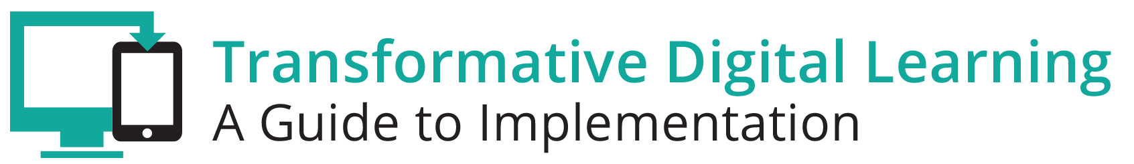

Facilitator Guide – Essential Components of Digital Learning Plans

What is in this Guide?
This guide provides facilitators with the information they need to conduct a workshop around the essential components of state and/or district digital learning plans. It is our assumption that the facilitator will have at least a basic knowledge about learning in the digital age. Ideally, the facilitator should understand the basic components of a digital learning plan.

This guide provides facilitators with step by step activities, with suggested times for each activity, as well as narrative content and resources to support the topic. This guide is accompanied by a presentation slide deck for use during the workshop. It also includes a link to the logistics spreadsheet to help facilitators plan the workshop. Logistics include recommendations for audio visual, catering, registration and outreach.

This facilitator guide can be used in its current format or it is easily customizable to meet your needs. The guide is organized as follows:
- Purpose of the workshop
- Objectives for participants
- Key sections with suggested times
- Resources

Purpose of the Workshop
The goal of this session is for participants to learn more about state and district digital learning plans and the essential components of those plans.

Objectives for Participants
- Hear from your colleagues on how technology supports their student learning goals.
- Explore federal policy shifts around transforming learning in the digital age.
- Examine exemplar digital learning plans and identify common components across the plans.
- Create a digital learning plan that can be used as model in your state or district.
- Develop and maintain relationships with other state leaders.

Session Overview (Total time: 2 hours)
- Welcome and Introductions (10-15 minutes)
- Background (15-20 minutes)
- Brainstorming Rate It Activity (5-10 minutes)
- Exploring Digital Learning Plans & Creating a Model Plan (60 minutes)
- Policies and Initiatives (10-15 minutes)
- Reflection Activity (10 minutes)

**Please note – the timing of activities requires a rapid paced session. Each facilitator will need to consider their audience (as related both to background knowledge and size) as well as future opportunities for professional learning opportunities around the topic and then choose the activities and time commitment for each.

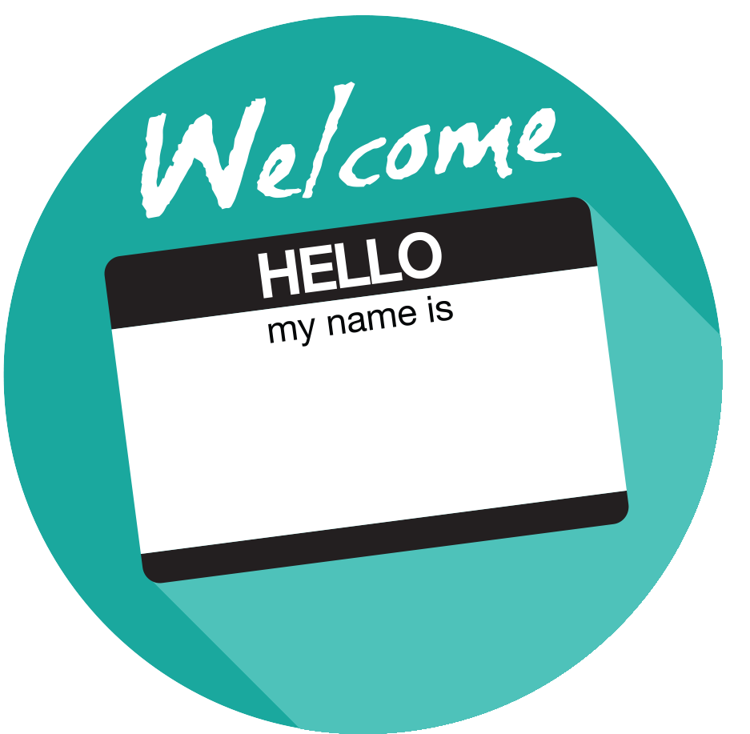
Welcome and Introductions (10-15 minutes)
Facilitator Note: Introduce yourself, review the agenda and logistics for the session. Introduce the welcome activity to help you better understand who is in the audience and the role technology plays in supporting learning in the digital age. If you have a large group, ask participants to complete this in small groups via individual tables rather than as a whole group. You may also choose an activity from the Activity Toolbox.

What is Important to You?
Have participants introduce themselves (individually) and share one goal their school or district has for student learning and share one way technology might support them in furthering that learning goal. This could be related to infrastructure, content, devices, professional development, funding, or any area they would like to lift up.

Background (15-20 minutes)
Facilitator Note: This section includes a brief overview of learning in the digital age and presents four state digital learning plans. These plans will be the basis of discussion and activities for the rest of the workshop. The facilitator may modify this section to include district digital learning plans instead of state plans. The resources section includes links to district plans.

Overview
Technology is an essential component of learning today. With digital applications, tools and resources, students can create content, interact with experts, collaborate with peers and participate in simulation activities. Personalized learning experiences put students at the center of learning and empower students to take control of their own learning through flexibility and choice. The Every Student Succeeds Act (ESSA) acknowledges technology’s role in transforming learning and includes definitions for digital learning and blended learning, and references technology throughout the legislation. In the Non-Regulatory Guidance Student Support and Academic Enrichment Grants publication provides an overview of activities LEAs may consider as they prepare for implementation of the effective use of technology (ESEA Section 4109). Specific activities include: supporting high-quality professional development for educators, school leaders, and administrators to personalize learning and improve academic achievement; building technological capacity and infrastructure; carrying out innovative blended learning projects; providing students in rural, remote, and underserved areas with the resources to benefit from high-quality digital learning opportunities; and delivering specialized or rigorous academic courses and curricula using technology, including digital learning technologies.
Similarly, the National Education Technology Plan (NETP) calls for a “revolutionary transformation rather than evolutionary tinkering” in education and recognizes that we must leverage technology to provide engaging and powerful learning experiences for all students. Technology offers all students – urban, rural, low-income, ESL, special needs, high achieving – the opportunity to engage in dynamic learning activities. Education leaders at the federal, state, and local level have the opportunity to provide leadership to ensure that all students have personalized, engaging learning experiences.
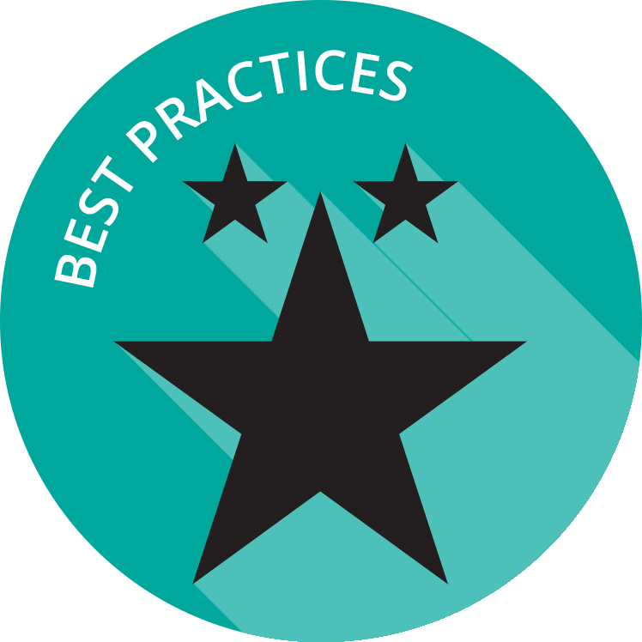

State Digital Learning Plans
Strategic planning is essential to achieve our goals for learning in the digital age. This section highlights select states with digital learning plans and provides a brief overview of each of these plans:
- Indiana
- North Carolina
- Utah
- Wisconsin

Indiana
The Indiana Tech Plan provides a snapshot of where each corporation (district) is with regard to infrastructure and the integration of student technology in learning. Each district completes an annual technology planning survey. Key components of the survey include: technology integration; infrastructure; platforms; virtual courses professional development; 1:1 status; devices; and funding. Indiana publishes the results of the survey at Tech Plan Maps. Users can select a corporation to see a synopsis of their technology planning survey.

North Carolina
The North Carolina Digital Learning Plan creates a long-term strategy that sets directions and priorities, supports innovation, and provides resources to enable educators and students to benefit fully from teaching and learning in the digital age. The plan also provides recommendations for state actions that will guide and support K-12 schools in this process. Key components of the plan are: technology infrastructure and devices; human capacity; content; instruction and assessment; local digital learning innovations; policy and funding; and regional and state support structures.

Utah
The Utah State Board of Education (USBE), Utah Education and Telehealth Network (UETN), the legislature and local school systems worked together to best leverage the power of technology for learning. Utah’s Master Plan: Essential Elements for Technology Powered Learning provides a framework for implementing digital learning. Each element of the plan includes the rationale, state responsibilities and district responsibilities. Key sections are: professional learning, communication, infrastructure; digital devices, content and software; technical support; procurement; and funding.
Wisconsin
Wisconsin developed a comprehensive digital learning plan for PK-12. Wisconsin adopted the Future Ready Framework as a way to organize key priorities and planning tools for districts. The Future Ready vision focuses on equitable, personalized, applied, and engaged digital learning for all students. The state encourages districts to consider the following areas when implementing their vision: instruction, learning and assessment; empowering, innovative leadership; technology & hardware; professional learning and building capacity; and data and privacy.

Facilitator Note: Engage participants in a general discussion about where they are in the digital learning plan process. Choose whole group, table or partner discussion depending on timing and size of group.

Discussion Questions
- Where is your state/district in the development of a digital learning plan?
- Do you plan to develop a digital learning plan in the next 6 months? Next 12 months?
- What factors hinder your planning process? Leadership? Staff time?

Facilitator Note: Choose the featured video or select one of your own. This activity will help support the mindset of the participants; provide an opportunity for dialogue; and share experiences in and among leaders. Choose whole group, table or partner discussion depending on timing and size of group

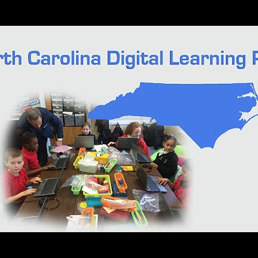

North Carolina Digital Learning Plan
It is an exciting time for North Carolina education and the Digital Learning Plan is just one more way we are making investments to improve education in our state.
https://www.youtube.com/watch?v=ioNGZCXxsv8

Discussion Questions:
- Share one element of their plan that your state/district can easily adopt.
- How are you considering equity issues across your state/district?
- Does your state/district show leadership in moving towards learning in the digital age?
- What funding options are you considering?
- Is your state/district considering competency-based education?
- How are you addressing personalized learning in your state/district?
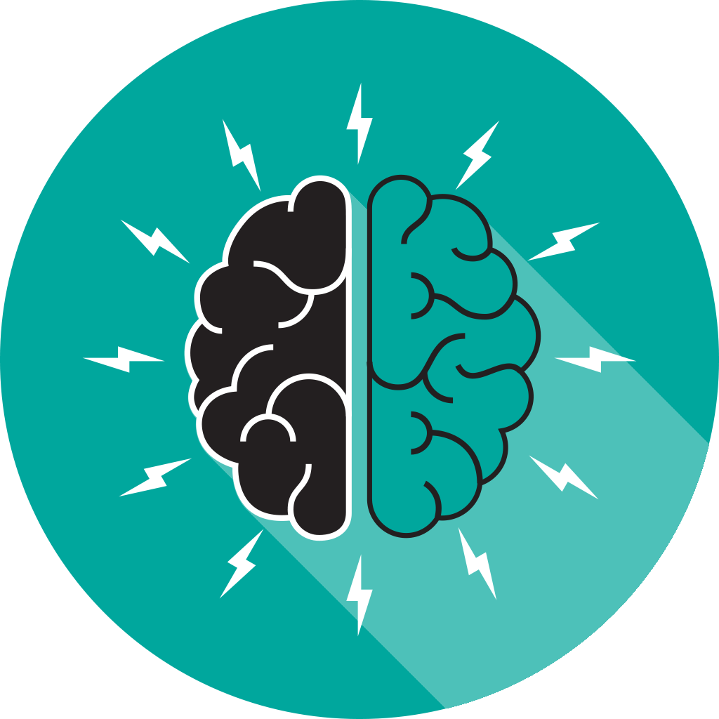
Brainstorming Rate It Activity (10 minutes)

Facilitator Note: Either via poster paper and markers or online collaboration tools, have the participants identify where they are in technology implementation and integration. Facilitator may also choose a brainstorming activity from the Activity Toolbox.
- Allow participants to respond the questions individually.
- Have the tables discuss their responses.
- If time, have a couple of tables share with the whole group.

On a scale of 1-10, with 10 as the best (we have everything we need and the functionality we need), ask participants to rate their school/district/state on each of the following:

- Bandwidth
- Wireless access
- Devices
- Computers/laptops/tablets
- Digital instructional materials
- Virtual courses
- Assessments
- Content management system
- Learning management system

Exemplar Rapid Fire Presentations (25-30 minutes)

Facilitator Note: Ask two exemplar states/districts to share their digital learning plans. If you don’t have a presenter - leverage the exemplar states included in this guide. The presentations should be 5-7 minutes and prepared in advance of the workshop. Additional information about presentations can be found in the Logistics resource.

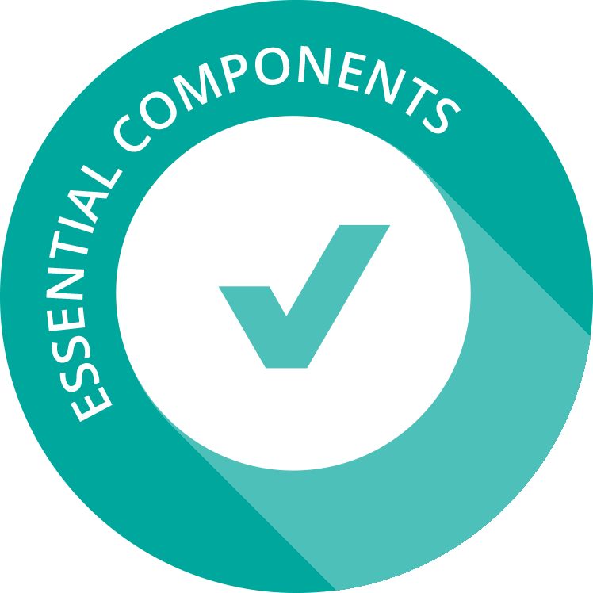

Exploring Digital Learning Plans & Creating a Model Plan (60 minutes)

Facilitator Note: Either via poster paper and markers or online collaboration tool, have the participants create a model state digital learning plan. This activity can also be modified to create a district digital learning plan.

Create a Model Plan Activity
Teams will review the four state digital learning plans and create a model state digital learning plan using components from the four exemplar state plans.

Small Group (30 minutes)
- In small groups, each team will begin by reviewing the four state digital learning plans and create a model state digital learning plan using the best components from the four state plans.
- As teams review the plans, make note of the components in each plan, particularly those that align with the learning goals of their own district or state. Each team will select 5-7 components to include in a model plan.
- As shown in the table below, some components are in multiple state plans while others may only be in one. If the component is found in more than one state, select one state version to use. Alternatively, teams may choose to rewrite the component to combine elements from each state.
- Next, have teams reflect on any gaps that exist and add any additional components not included in the state plans.
- The team should note which components from each state plan are included in their model district digital learning plan.

Whole Group (30 minutes)
Have each team pair with another team to share their model plan.

State Digital Learning Plans  Components | Indiana | North Carolina | Utah | Wisconsin
Infrastructure
Devices
Technology & Hardware
Platforms
1:1
Funding
Human Capacity/Professional Learning
Content, Instruction, Assessment
Virtual Courses
Local innovations
Regional/state support
Communication
Procurement
Empowering Leadership
Data and Privacy

Policies and Initiatives (10-15 minutes)
Facilitator Note: State and local leaders can build capacity for the implementation of digital learning by coordinating efforts and engaging in strategic planning. These questions can also be used as key topic areas for follow-up workshops.

Discussion Questions
- Are there local policies/practices that can be updated to support digital age learners?
- What policies impact the development of a digital learning plan in your state/district?
- Which stakeholders need to be involved in the conversations?

Reflection and Wrap Up (5-10 minutes)
Facilitator Note: Take a few moments to reflect on the session, share details about additional events related to the remainder of the day and engage the audience to take action when they return to their schools/districts. Use this activity or choose another one from the Activity Toolbox.

Circle, Square, Triangle Activity
By table, ask participants to discuss where they are in the process using the reflective concept of circle, square, triangle.

Circle – You are still circling these ideas in your mind
Square – You understand the challenge
Triangle – You are ready to implement change

Based on the reflection activity, identify the next steps for your state, district or school.

Wrap Up
Facilitator Note: The facilitator wraps up the day and shares resources with participants. Sample language: “This is only the first step of many steps in supporting teachers and students for learning in the digital age. I encourage you to follow up on our reflection activity during the next few weeks and continue to collaborate with your peers. Think about what tools and resources you can use to maintain relationships and encourage collaboration, as well as identify opportunities for on-going professional learning and workshops.

Resources
The US Department of Education does not endorse any resources; instead they are provided to assist the facilitator in preparing for the workshop. The facilitator can also share these resources with participants to support on-going professional learning and school/district planning after the workshop. For example, some districts have used the NETP for on-going book studies throughout the school year to support the development and refinement of technology initiatives.

US Department of Education Resources
Building Technology Infrastructure for Learning
Every Student Succeeds Act (ESSA)
National Education Technology Plan (NETP)
Non-Regulatory Guidance: Student Support and Academic Enrichment Grants

Facilitator Guide Resources
Baltimore County Public Schools 2015-2019 Technology Plan
ESSA, EdTech and the Future of Education
Indiana annual technology planning survey
Indiana Tech Plan
New York City Department of Education Strategic Technology Plan 2015-2020
North Carolina Digital Learning Plan
Utah’s Master Plan: Essential Elements for Technology Powered Learning
Wisconsin Digital Learning Plan

