Facilitator Guide – Digital Citizenship

What is in this Guide?
This guide provides facilitators with the information they need to conduct a workshop around the essential components of state and/or district digital learning plans. It is our assumption that the facilitator will have at least a basic knowledge about learning in the digital age. Ideally, the facilitator should understand the basic components of a digital learning plan.
This guide provides facilitators with step by step activities, with suggested times for each activity, as well as narrative content and resources to support the topic. This guide is accompanied by a presentation slide deck for use during the workshop. It also includes a link to the logistics spreadsheet to help facilitators plan the workshop. Logistics include recommendations for audio visual, catering, registration and outreach.
This facilitator guide can be used in its current format or it is easily customizable to meet your needs. The guide is organized as follows:
- Purpose of the workshop
- Objectives for participants
- Key sections with suggested times
- Resources

Purpose
The goal of this session is to provide participants, typically school and district leaders, with the opportunity to understand the issues and responsibilities around digital citizenship.

Objectives
- Learn more about digital citizenship
- Discover best practices from peers
- Discuss how your school/district is addressing digital citizenship
- Explore resources used by other schools/districts
- Develop and maintain relationships with other district and state leaders

Session Overview (90 minutes)
- Welcome and Introductions (5-10 minutes)
- Background (10 minutes)
- Exemplar Rapid Fire Presentations (15-20 minutes)
- Brainstorming Activity (10-15 minutes)
- How are You Addressing Digital Citizenship (15-20 minutes)
- Reflection and Wrap Up (5-10 minutes)

**Please note – the timing of activities requires a rapid paced session. Each facilitator will need to consider their audience (as related both to background knowledge and size) as well as future opportunities for professional learning opportunities around the topic and then choose the activities and time commitment for each.

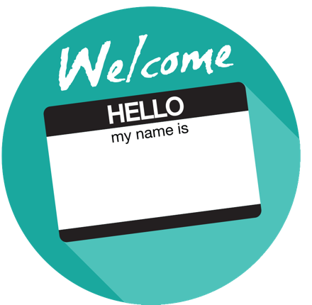
Welcome and Introductions (5-10 minutes)
Facilitator Note: Introduce yourself, review the agenda and logistics for the session. Introduce the welcome activity. This activity will help the facilitator better understand the audience. If you have a large group, ask the participants to complete this via individual tables vs whole group. You can also choose an activity from the Activity Toolbox.

Multiple Identities
Have the participants think for a moment about the number of different (unique) usernames they have in the digital world. They may want to think about email account names, social media names, usernames to log in to sites for banking, bill paying, utilities, shopping, and so on. Sometimes they can use the same username over and over, but some sites require a certain format or allow the user to create their own. Participants should try to count the number of unique names they have online – if a name is repeated on multiple sites, it should only be counted once. Have participants line up around the room in order of the number of identities. If people have the same number, they should cluster together. Once all are lined up, note the greatest number of identities, the fewest number of identities, and what number of identities was most common to the room. Reflect on how each of these identities represents your digital footprint.

Background (10 minutes)
Facilitator Note: Share some general background information about digital citizenship and the elements of digital citizenship.

Overview
As we implement learning in the digital age, there is an increasing need to foster conversation about the responsibility that students, teachers, parents and education leaders have in the digital space.

What is Digital Citizenship?
Digital citizenship establishes a set of norms and practices regarding appropriate and responsible technology use. Digital citizenship requires a whole-community approach to thinking critically, behaving safely, and participating responsibly online. - Ed Tech Developer’s Guide

“Digital Citizenship is more than just a teaching tool; it is a way to prepare students/technology users for a society full of technology. Digital citizenship is the norms of appropriate, responsible technology use.” – Digital Citizenship, Using Technology Appropriately

Nearly all of ISTE Standards address digital citizenship as one of the aspects of education technology that all members of a school or district should support. Essentially, the standards focus on the safe, legal and ethical use of technology in schools. – ISTE Standards
Digital Citizen: Students recognize the rights, responsibilities and opportunities of living, learning and working in an interconnected digital world, and they act and model in ways that are safe, legal and ethical. 2016 ISTE Standards for Students

Digital Citizenship, Using Technology Appropriately identifies the following nine key elements for digital citizenship.
- Digital access: Advocating for equal digital rights and access is where digital citizenship starts.
- Digital etiquette: Rules and policies aren’t enough — we need to teach everyone about appropriate conduct online.
- Digital law: It’s critical that users understand it’s a crime to steal or damage another’s digital work, identity or property.
- Digital communication: With so many communication options available, users need to learn how to make appropriate decisions.
- Digital literacy: We need to teach students how to learn in a digital society.
- Digital commerce: As users make more purchases online, they must understand how to be effective consumers in a digital economy.
- Digital rights and responsibilities: We must inform people of their basic digital rights to privacy, freedom of speech, etc.
- Digital safety and security: Digital citizens need to know how to protect their information from outside forces that might cause harm.
- Digital health and wellness: From physical issues, such as repetitive stress syndrome, to psychological issues, such as internet addiction, users should understand the health risks of technology.

Facilitator Note: Choose the featured video or select one of your own. This activity will help support the mindset of the participants; provide an opportunity for dialogue; and share experiences in and among leaders. Choose whole group, table or partner discussion depending on timing and size of group.

Making Digital Citizenship Personal
See the strategies from a teacher who makes digital citizenship personal for her middle school students. https://www.commonsensemedia.org/videos/making-digital-citizenship-personal

Discussion Questions
- How is your district/school teaching students about digital citizenship?
- Share one thing from this video that you could implement right away in your school.

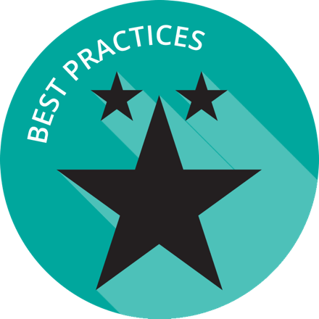

Exemplar Rapid Fire Presentations (15-20 minutes)
Facilitator Note: Ask two exemplar school/districts to share their background and experience with digital citizenship. If you don’t have a presenter - leverage the exemplar districts listed at the bottom of this page. The presentations should be 5-7 minutes and prepared in advance of the workshop. Additional information about presentations can be found in the Logistics resource.

Discussion Questions
- How is your school/district similar to the exemplar?
- Are there policies/practices shared that your school/district can implement within the next quarter?

Brainstorming Digital Citizenship (10-15 minutes)
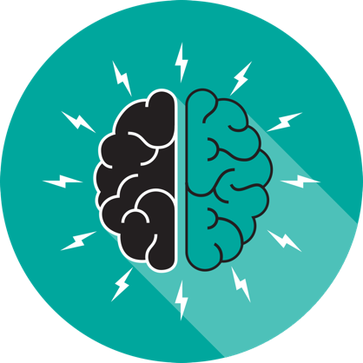
Facilitator Note: Either via poster paper and markers or online collaboration tools have the participants identify their knowledge around digital citizenship. Facilitator can choose AnswerGarden, a free online brainstorming tool encouraging real time audience participation and classroom feedback or another brainstorming activity from the Activity Toolbox.

Discussion Questions
- How do students learn about digital citizenship?
- How do students demonstrate mastery of digital citizenship?
- How can your school recognize students for model digital citizenship?
- How do teachers/ administrators learn about digital citizenship?
- How do teachers/ administrators demonstrate digital citizenship?
- How might schools recognize teachers/ administrators for model digital citizenship?

How are You Addressing Digital Citizenship (15-20 minutes)
Facilitator Note: Use this activity to explore more deeply how participants are addressing digital citizenship with teachers, students and parents. The facilitator introduces the activity or chooses another activity from the Activity Toolbox.

Gallery Walk Activity
Post chart paper with one question per paper around the room. Divide participants into small groups. Each group should stand in front of one of the chart papers. Ask participants to write ideas or responses on the chart paper. If a response is already on the paper, the participant can simply place a check mark beside the idea rather than writing it again. After completing the first question, participants can rotate around the room until they have responded to each of the questions. After all are complete, the facilitator can review the responses with the whole group and share the ideas with the most check marks.

Discussion Questions
- What resources do you provide teachers around digital citizenship?
- How do your students learn about digital citizenship?
- At what age, does your school start teaching students about digital citizenship?
- How are you dealing with cyberbullying?
- How do you address copyright laws?
- How do you provide outreach to parents about digital citizenship?

Reflection and Wrap Up (5-10 minutes)
Facilitator Note: Take a few moments to reflect on the session, share details about additional events related to the remainder of the day and engage the audience to take action when they return to their schools/districts. Use this Audience Challenge activity or choose another one from the Activity Toolbox.

Audience Challenge
What can you do when you return to your position to help move the marker forward?
- Create a calendar appointment to remind yourself
- Mail a postcard to yourself
- Invite your colleagues to lunch to discuss the issues

Based on the reflection activity, identify the next steps for your state, district or school.

Wrap-Up
Facilitator Note: The facilitator wraps up the day and shares resources with participants. Sample language: “This is only the first step of many steps in supporting teachers and students for learning in the digital age. I encourage you to follow up on our reflection activity during the next few weeks and continue to collaborate with your peers. Think about what tools and resources you can use to maintain relationships and encourage collaboration, as well as identify opportunities for on-going professional learning and workshops.

Resources
The US Department of Education does not endorse any resources; instead they are provided to assist the facilitator in preparing for the workshop. The facilitator can also share these resources with participants to support on-going professional learning and school/district planning after the workshop. For example, some districts have used the NETP for on-going book studies throughout the school year to support the development and refinement of technology initiatives.

US Department of Education Resources
Building Technology Infrastructure for Learning
Every Student Succeeds Act (ESSA)
National Education Technology Plan (NETP)
Stories of Ed Tech Innovation

Facilitator Guide Resources
Common Sense Education, Digital Citizenship
CoSN K-12 Privacy Toolkit for School Leaders
SETDA, Navigating the Digital Shift
Student Film: Don’t Press Send

