Facilitator Guide – Connectivity

What is in this Guide?
This guide provides facilitators with the information they need to conduct a workshop around the essential components of state and/or district digital learning plans. It is our assumption that the facilitator will have at least a basic knowledge about learning in the digital age. Ideally, the facilitator should understand the basic components of a digital learning plan.
This guide provides facilitators with step by step activities, with suggested times for each activity, as well as narrative content and resources to support the topic. This guide is accompanied by a presentation slide deck for use during the workshop. It also includes a link to the logistics spreadsheet to help facilitators plan the workshop. Logistics include recommendations for audio visual, catering, registration and outreach.
This facilitator guide can be used in its current format or it is easily customizable to meet your needs. The guide is organized as follows:
- Purpose of the workshop
- Objectives for participants
- Key sections with suggested times
- Resources

Purpose of the Workshop
The goal of this session is to provide participants, typically school and district leaders, with the opportunity to gain knowledge and resources to develop and enhance their infrastructure to support digital learning.
Objectives
- Learn more about connectivity options for networks, Wi-Fi, and devices from colleagues and experts
- Hear from colleagues on best practices for implementation
- Collaborate with colleagues on key questions related to connectivity implementation
- Acquire resources to support infrastructure planning and implementation
- Develop and maintain relationships with other district and state leaders

Session Overview (Total time: 90 minutes)
- Welcome and Introductions (5-10 minutes)
- Background (5-10 minutes)
- Connectivity Considerations and Recommendations (10-15 minutes)
- Exemplar Rapid Fire Presentations (15-20 minutes)
- Brainstorming Activity (10 minutes)
- Broadband/Wireless Capacity Activity (20-25 minutes)
- Policies and Initiatives (5-10 minutes)
- Reflection and Wrap Up (5-10 minutes)

**Please note – the timing of activities requires a rapid paced session. Each facilitator will need to consider their audience (as related both to background knowledge and size) as well as future opportunities for professional learning opportunities around the topic and then choose the activities and time commitment for each.

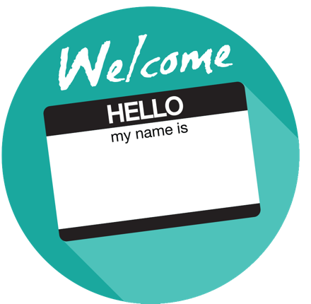
Welcome and Introductions (5-10 minutes)
Facilitator Note: Introduce yourself, review the agenda and logistics for the session. Introduce the welcome activity. This activity will help the facilitator better understand the audience. If you have a large group, ask the participants to complete this via individual tables vs whole group. Content may be gathered via Google Doc, online polling tool or chart paper. You can also choose an activity from the Activity Toolbox.

I’m Here and I’m In Activity
Ask participants to share their name, title and in 1 short sentence why they are attending the meeting. To help focus participants on the meeting at hand and not multitask ask them to leave their personal and professional woes at the door and share “I”m here and I’m in” after their statement.

Example: My name is Maria Lopez, I am a district curriculum advisor and I am participating to help support our district shift to digital instructional materials. My daughter is home sick with stomach flu but she has a great sitter so… “I’m here and I’m in”.

Background (10 minutes)
Facilitator Note: Share some general rationale about building technology infrastructure and increasing connectivity for student learning opportunities.

Overview
An essential component for learning is a comprehensive infrastructure that provides all students and teachers with the resources they need anytime, anywhere. The underlying principle is that infrastructure includes people, processes, learning resources, policies, and sustainable models for continuous improvement in addition to broadband connectivity, hardware, software, and administrative tools. A robust infrastructure enables schools to expand learning options, empowering students to create content, participate in virtual courses that may not be available on their campuses, and to collaborate with experts or other students remotely. Building Technology Infrastructure for Learning is a guide that helps districts address the planning and leadership demands associated with technical upgrades, identifies the key questions for assessing conditions in schools and districts and sets technical goals for the future. Using this and other tools, state and local leaders can build capacity for infrastructure by coordinating efforts and engaging in strategic planning.

High-Speed Broadband
High-speed broadband is essential for equitable access in schools for all students, as bandwidth capacity determines which digital instructional materials and educational applications students and educators can effectively leverage in the classroom. Reliable connectivity, like water and electricity, is foundational to creating an effective learning environment. The importance of designing high-capacity and widely available networks, including the utilization of wireless networks is essential for meeting our learning powered by technology goals.

Quick Facts
- Cisco predicts that global internet traffic will be over 50,000 Gbps by 2019, more than triple the current traffic rate.
- Education Networks of America (ENA), based on its experience delivering connectivity to over 5,500 schools and libraries, continues to observe and projects into the future an internet growth rate of 65% per year.
- EducationSuperHighway predicts that the typical school district will need to triple its bandwidth in the next three years.
- CoSN’s Infrastructure Survey states that 39% of districts report projected growth in the next 18 months between 50% and 499%.

Facilitator Note: Choose the featured video or select one of your own. This activity will help support the mindset of the participants; provide an opportunity for dialogue; and share experiences in and among leaders. Choose whole group, table or partner discussion depending on timing and size of group

Attaining Broadband District-Wide, Howard-Winneshiek Community Schools, Cresco, IA

Howard Winneshiek Community Superintendent John Carver discusses how to bring a rural district to a place of connectivity district-wide.

Discussion Questions
- Share one thing that is similar about your school/district and the featured video.
- How has your state/district worked with business and non-profit partners to increase broadband access and speed?
- Do your students lack robust broadband access at home?

Connectivity Considerations and Recommendations (10 minutes)
Facilitator Note: Use the notes below to share details regarding connectivity best practices and considerations. This will provide the audience with additional background knowledge and resources.

Infrastructure Design
As evidenced in the Every Student Succeeds Act (ESSA), there is an increased emphasis on digital learning. The Student Support and Academic Enrichment Grants (SSAEG) block grant program in ESSA specifically addresses technology for academic achievement and growth with the authorization of $1.65 billion. However, only 15% of the 60% of funds allowed for activities to support the effective use of technology can be used for building technology capacity and infrastructure. The recently updated 2017 National Education Technology Plan addresses K-12 infrastructure and identifies the essential components necessary to support learning: ubiquitous connectivity; powerful learning devices; high-quality digital learning content; and Responsible Use Policies (RUPs). The Building Technology Infrastructure for Learning Guide covers four main areas related to connectivity:
- Understanding types of available connectivity
- Four paths for connecting districts and schools
- Cost drivers and funding sources to consider
- Special considerations for rural areas

Internet Service Provider (ISP) Recommendation
Updated in 2016, SETDA provides broadband capacity recommendations for connection to the internet service provider (ISP) based on the size of the district (number of students). This method allows education stakeholders to better understand some of the nuances between very small districts (under 1,000 students) compared to large districts (over 10,000 students). The ISP recommendations are based on research; analysis of data sets from districts across eight states regarding both capacity and usage; and consultation with experts in the field.

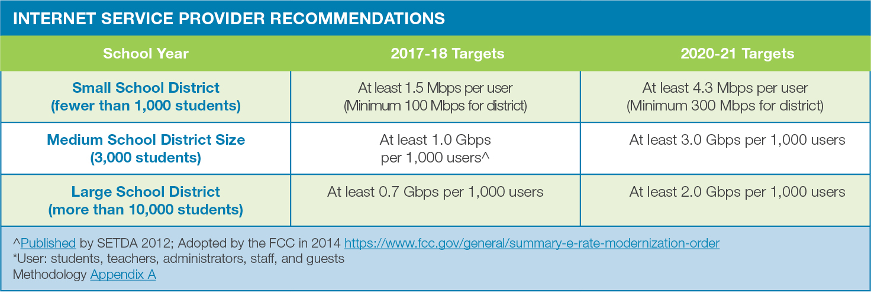
Wide Area Network Recommendation
SETDA recommends that for the 2017-18 and 2020-21 school years, districts should have at least 10 Gbps per 1,000 users for wide area network (WAN) access. Based on recent trends, research and consultation with experts in the field, SETDA expects that WAN requirements will come closer in line to ISP connections as districts utilize cloud-based services, as well as the advent of virtualization—shifting the capacity requirements from the WAN to the ISP connection. Therefore, the WAN recommendations for 2017-18 remain the same for 2020-21.

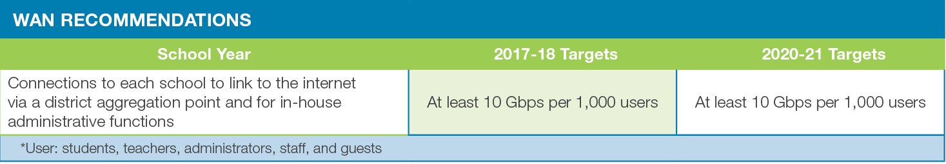

Network Design
Designing district networks for both the short and long-term that are open, filtered, flexible, and support multiple devices for teachers and students is critical. When designing networks, districts need to assure that the internet connections are used effectively. That means the school will need to have access to the resources necessary to use the internet, including school- or student-owned computers or devices, teacher professional development or training, software, an internal network, and technical support. For some schools, making full use of these connections may require that those schools modify their curriculum so that it effectively incorporates digital age learning. Districts and schools may need to modify their security policies to allow teachers and students to access rich digital resources on the internet or to engage in high-quality real-time collaboration or communication with experts, parents, and community members, or other schools. It is also important that networks are created by IT experts with input from all stakeholders, administrators, teachers, students and parents so that everyone has a voice in the needs of the network.

Tip
Building for Future Capacity: Districts should consider arranging with their service provider for underlying transport circuits that can easily be upgraded and accommodate at least 25% more internet capacity than their purchased capacity levels so that they can easily and dynamically upgrade as their usage demands. For example, a 1,500 student school district with a 5.4 Mbps/user recommendation in 2020-2021 would need to buy 8 Gbps. SETDA recommends purchasing or requesting circuit capacity of 10 Gbps to transport the 8 Gbps, just to provide some immediately available capacity should an upgrade be required.

Wireless Access Design
As districts and schools consider Wi-Fi access, planning is essential. Districts with robust wireless networks and wireless companies support a 5-year wireless plan with updates every year. Following are some interconnected questions to consider as you begin to plan for high-speed Wi-Fi across schools and districts.

Exemplar Rapid Fire Presentations (15-20 minutes)
Facilitator Note: Ask two exemplar school/districts to share their background and experience regarding connectivity. The presentations should be 5-7 minutes and prepared in advance of the workshop. Additional information about presentations can be found in the Logistics resource.

Discussion Questions
- How is your school/district similar to the exemplar?
- Are there policies/practices shared that your school/district can implement within the next quarter?

Brainstorming Activity (10 minutes)
Facilitator Note: Either via poster paper and markers or online collaboration tools have the participants brainstorm about digital learning and connectivity. The facilitator can use AnswerGarden, a free online brainstorming tool encouraging real time audience participation and classroom feedback. The facilitator can select the following sample questions to start the discussion.

Sample Questions
- What do you think of when you hear the word “connectivity”?
- Where does your district/school have wireless hotspots?
- What types of devices do your teachers and students use?

Broadband/Wireless Capacity Activity (25-30 minutes)
Facilitator Note: Based on the interests of the group, use this activity to focus on broadband, Wi-FI, or some combination of the two topics. The facilitator introduces the Share and Move activity where participants discuss the sample questions with one another and quickly move to discuss the same question with another participant.

Small Group (15-25 minutes)
The facilitator chooses 3-5 key questions for participants to discuss from the key questions section of the module. Anticipate 5 minutes per round. We suggest doing 3-5 rounds, depending on the number of questions you want to explore more deeply.

Arrange participants in two parallel lines about two feet apart. You should be directly across from a person in the opposite line. Each person will be given a question (4 minutes)
Row 1 X X X X
Row 2 O O O O
Members of Row 1 will have 2 minutes to talk to the person directly opposite them in Row 2. After two minutes the roles will switch and Row 2 will have two minutes to respond to the same question. After Round 1, participants will rotate counter clockwise. Continue this process for the next rounds. Each new round starts with a new question (4 minutes).
Row 1 X X X X
Row 2 O O O O

Whole Group (10 minutes)
After you have completed the rounds, bring the group together and ask participants to share some of their discussions.

Discussion Questions
- How Is your district/school building capacity to support an evolving infrastructure for learning in the digital age?
- Is the broadband infrastructure sufficient for simultaneous access for most users?
- How is wireless connectivity supporting connectivity?
- Is wireless available on campus in all learning spaces?
- Does your network have adequate security and levels of access?
- Does your school/district have adequate internet access to fully utilize digital instructional materials and resources (i.e., speed, reliability)?
- Do your students and teachers have access to devices at school and outside of school?

Policies and Initiatives (5-10 minutes)
Facilitator Note: Encourage discussion on how state and local leaders can build capacity for connectivity by coordinating efforts and engaging in strategic planning. State policies in support of broadband and Wi-Fi access provide guidance to districts and schools to help ensure long-range infrastructure planning to support robust broadband access in schools.

Discussion Questions
- Does your state have policies/guidelines for broadband connectivity?
- Are there local policies/practices that can be updated to support equitable connectivity for all learners?
- Which stakeholders and influencers need to be involved in the conversations?

Reflection and Wrap Up (5 minutes)
Facilitator Note: Take a few moments to reflect on the session, share details about additional events related to the remainder of the day and engage the audience to take action when they return to their schools/districts. Use this Audience Challenge activity or choose another one from the Activity Toolbox.

Audience Challenge
What can you do when you return to your position to help move the marker forward?
- Create a calendar appointment to remind yourself
- Mail a postcard to yourself
- Invite your colleagues to discuss the issues

Based on the reflection activity, identify the next steps for your state, district or school.

Wrap-Up
Facilitator Note: The facilitator wraps up the day and shares resources with participants. Sample language: “This is only the first step of many steps in supporting teachers and students for learning in the digital age. I encourage you to follow up on our reflection activity during the next few weeks and continue to collaborate with your peers. Think about what tools and resources you can use to maintain relationships and encourage collaboration, as well as identify opportunities for on-going professional learning and workshops.

Resources
The US Department of Education does not endorse any resources; instead they are provided to assist the facilitator in preparing for the workshop. The facilitator can also share these resources with participants to support on-going professional learning and school/district planning after the workshop. For example, some districts have used the NETP for on-going book studies throughout the school year to support the development and refinement of technology initiatives.

US Department of Education Resources
Building Technology Infrastructure for Learning
Every Student Succeeds Act (ESSA)
National Education Technology Plan (NETP)
Stories of Ed Tech Innovation

Facilitator Guide Resources
Broadband Progress Report (2016),
CoSN’s 2016 Annual Infrastructure Survey
Roadmap for for 21st Century Learning Environments,
Smart Education Networks by Design (SEND)
State K-12 Broadband Leadership: Driving Connectivity and Access

Exemplars
Hawaii: 1:1 Access Program. The Hawaii State Department of Education (HIDOE) Access Learning pilot project focuses on providing schools with support and resources to use technology as a tool to transform teaching and learning beyond the four walls of the classroom. Schools applied and were selected based on their network capacity, readiness to implement large scale school-wide change, ability to participate in professional development, identification of a school level project team, sufficient on-site technology coordinator support, and capacity to participate in the project evaluation. Schools received one device per student and teacher, and a spare pool of equipment equivalent to six percent of their total device count.
Maine: The State of Maine Department of Education’s Maine Learning Technology Initiative (MLTI) led a multi-state effort to undertake the procurement process for equipment and services to empower a wireless student-centered, digital learning environment. The multi-state effort was coordinated with participating National Association of State Procurement Officials (NASPO) members on an as-requested basis, at various locations throughout the geographic regions of all participating NASPO members. Request for Proposals (RFP) #201210412 is for the purchase of the aforementioned goods and services. The site includes the pricing on winning proposals.

North Carolina: The North Carolina Department of Public Instruction in partnership with The Friday Institute developed the state’s Wireless Infrastructure plan, which urged the state to take advantage of new E-rate funds through a state consortium. The approach was optimized against the FCC $150-per-student allocation, and sought out a mix of providers who could deliver wireless equipment, Ethernet switches, wiring, configuration, and install and manage services eligible under the allocation. In 2015, the state provided Wi-Fi to over 375,000 students at an average cost of only $116 per student (pre-discount).

New Mexico: This program applied lessons learned from North Carolina and Alabama to aggregate buying power for Category 2 (Wi-Fi and networking equipment). The statewide master contract, accessed by all school districts and libraries has resulted in greater discounts than previous statewide contracts. Alabama has offered its Mini-Quote system to New Mexico, which functions like “eBay in reverse” as vendors compete with transparency on price in response to district requests against this contract. The 2016 funding year has seen more charter school participation in the E-rate program and an increase in pre-discount of about $15 million.

Virginia: In Fairfax County, Virginia, a school system with 180,000 students, there are 12,000 wireless access points and most classrooms have 2 access points to handle density. There are 190,000 unique users (110,000 students/staff and 80,000 guests). Fairfax has wireless access points in classrooms, hallways, cafeteria, gym, athletic fields, and the playground. Wireless access allows staff to have instant access to emergency contacts if a student is sick or injured.

