Facilitator Guide – Collaborative Leadership

What is in this Guide?
This guide provides facilitators with the information they need to conduct a professional learning session regarding the essential components of state and/or district digital learning plans. Ideally, the facilitator will have a basic understanding regarding learning in the digital age and some experience with the basic components of digital learning plans.

This guide includes step by step activities, with suggested times for each activity, as well as narrative content and resources to support the topic. This guide is accompanied by a presentation slide deck for use during the workshop. It also includes a link to the logistics spreadsheet to help facilitators plan the workshop. Logistics include recommendations for audio visual, catering, registration and outreach.

This facilitator guide can be used in its current format or it is easily customizable to meet your needs. The guide is organized as follows:
- Purpose of the workshop
- Objectives for participants
- Key sections with suggested times
- Resources

Purpose of the Workshop
The goal of this session is for participants to learn more about how collaborative leadership supports strategic planning around digital learning.

Objectives for Participants
- Review the key components for collaborative leadership to support digital learning
- Learn about strategic planning tools for digital learning implementation
- Think about who the appropriate education leaders are in your state/district to coordinate the strategic planning process
- Discuss with colleagues what teaching and learning would look like if leaders from across disciplines (i.e., academics, assessment, technology) collaborated on aligned digital learning solutions
- Discuss some of the key policies and practices that impact and support learning in the digital age
- Develop and maintain relationships with other district and state leaders

Session Overview (Total time: 90 minutes) **
- Welcome and Introductions (5-10 minutes)
- Background (10 minutes)
- Strategic Planning Tools (5-10 minutes)
- Brainstorming Stickie Activity (5-10 minutes)
- Exemplar Rapid Fire Presentations (10-15 minutes)
- Collaborative Leadership Activity (20-25 minutes)
- Policies and Initiatives (5 minutes)
- Reflection Activity (5 minutes)

**Please note – the timing of activities requires a rapid paced session. Each facilitator will need to consider their audience (as related both to background knowledge and size) as well as future opportunities for professional learning around the topic and then choose the activities and time commitment for each.

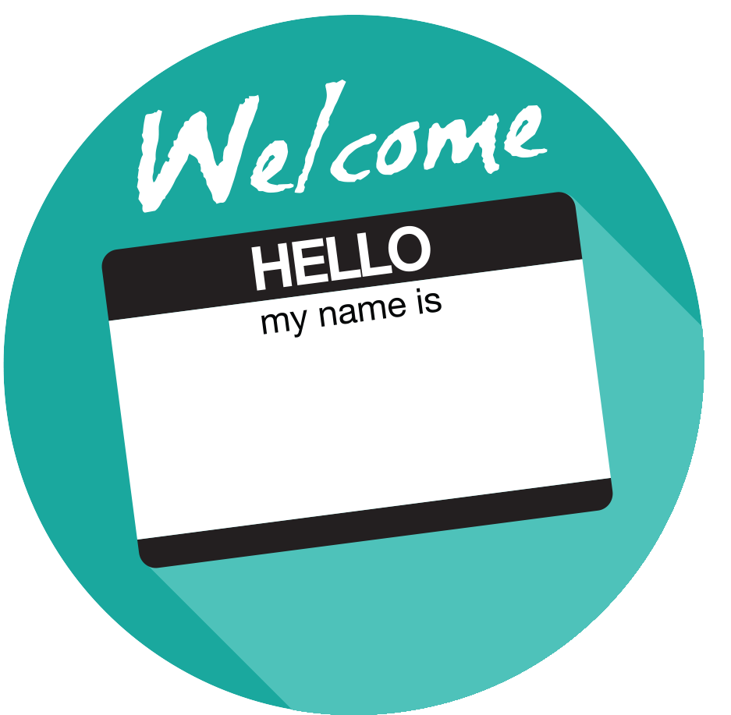

Welcome and Introductions (5-10 minutes)
Facilitator Note: Introduce yourself, review the agenda and logistics for the session. Introduce the welcome activity to help you better understand who is in the audience and how they use digital tools and resources. You may also choose an activity from the Activity Toolbox.

Take off, Touch Down
Learners stand and sit to answer questions as the facilitator polls the group. This is a great way to get participants up and moving. The facilitator makes a statement. Participants to whom the statement applies stand up ("Take Off"). Facilitator makes the next statement. For those standing, if the statement applies, remaining standing; otherwise sit down ("Touch Down"). For those seated, if the statement applies, stand up; otherwise remain seated.

Sample Questions
- Stand if you have worked in a school for 1 or more years
- Stand if you are an administrator
- Stand if you leverage digital tools in your classroom/school/district
- Stand if you are in a leadership position
- Stand if you leverage digital tools in your personal/social life

Background (10 minutes)

Facilitator Note: Provide an overview of collaborative leadership and the key components.

Overview
Digital learning is no longer a specialty area. Increasingly, leaders across state and district agencies in a variety of roles have shifted towards the use of technology as a primary tool for teaching and learning. It is critical that leaders across all areas are regularly engaged in collaborative planning discussions so that all leaders understand the district and school goals and the capacity to achieve those goals. This is especially true for academic, instructional, assessment and technology leaders. Looking across the state or district agencies, there are many leaders who are or should be involved in discussions and planning around digital learning:
- Chief Education Officer / Superintendent
- Chief Academic Officer or other Instructional Leaders
- Instructional Materials Leader
- Library Media Specialists
- Assessment Leader
- Digital Learning Leader
- Chief Technology Officer or other Technology Leader (Infrastructure, E-rate)
- Chief Financial Officer or other Business Leader
- Special Education Leader
- Title I/II/III Leaders
- Career Technical Education Leaders
- Professional Learning Leader

Key Components of Collaborative Leadership (Adapted from the NETP 2017)
- Develop a shared vision for how technology can support learning
- Seek input from a diverse team of stakeholders to adopt and communicate clear goals for teaching, leading, and learning that are facilitated by technology
- Communicate with all stakeholders by using appropriate media and technology tools and establish effective feedback loops
- Ensure that practitioners at the school and district level use and understand research

Shared Vision
As district and school leaders initiate the planning process, a shared vision serves as a firm compass point for how technology will support teaching and learning goals. Unlike a consensus in which everyone agrees, developing a shared vision represents buy-in from all stakeholders and reflects efforts to involve the right people at the right times. One way to achieve a shared vision is to use clear language in all aspects of the process. Districts that have carefully defined target audiences, goals, methods, timelines, responsibilities and outcomes enjoy less confusion because of better communication.

Collaboration with External Stakeholders
As schools move towards digital learning environments, it is necessary to foster leadership beyond district and school leaders to support the transition. The relationship between the district and the school board is an essential component for success, especially when implementing digital learning. The National School Boards Association guide, On the Same Page 2.0 is intended to spark conversation and suggestions among stakeholders and emphasizes the importance of information flow for continuous improvement and ownership by all stakeholders.
Facilitator Note: Choose the featured video or select one of your own. This activity will help support the mindset of the participants; provide an opportunity for dialogue; and share experiences in and among leaders. Choose whole group, table or partner discussion depending on timing and size of group.
Future Ready: Collaborative Leadership - Qualities & Attributes. https://youtu.be/cV-1iBGJb7U

Discussion Questions
- Share one thing that is similar about your school/district and the featured video.
- What relationships has your district/school formed in the community?

Strategic Planning Tools (10 minutes)
Facilitator Note: Use the notes below to share details about several tools that participants can use in the strategic planning process. This will provide the participants with additional background knowledge and resources.
International Society for Technology in Education ISTE Essential Conditions offers a research-backed framework to guide digital learning implementation. ISTE identifies 14 critical elements necessary to effectively leverage technology for learning.
- Shared vision
- Empowered leaders
- Implementation planning
- Consistent and adequate funding
- Equitable Access
- Skilled personnel
- Ongoing professional learning
- Technical support
- Curriculum framework
- Student-centered learning
- Assessment and evaluation
- Engaged communities
- Support policies
- Supportive external context

The Alliance for Excellence in Education offers an Interactive Planning Dashboard with a 5- step collaborative planning process. Upon completion, districts will have created a digital learning implementation plan, with research-based strategies, including stakeholder input, local context, and district team leadership responsibilities. The dashboard aligns research-based strategies and practitioner tested techniques with each district’s specific needs, allowing school district leaders to create systemic action plans for student-centered, personalized learning before purchasing additional technology—ensuring a much smoother implementation.
The Road Map for 21st Century Learning, developed in 2015 by the Cable Impacts Foundation, the Partnership for 21st Century Learning, and SETDA, with advice from dozens of experts and practitioners is a free strategic planning tool to help district/school leaders transform learning to meet the needs of students.

Brainstorming Sticky Activity (10-15 minutes)
Facilitator Note: Either via poster paper and markers or online collaboration tools have the participants answer some or all of the following discussion questions. This activity helps participants to think about collaborative leadership. The facilitator can also choose a brainstorming activity from the Activity Toolbox.

Independent (3-5 minutes)
Ask each participant to write down on a separate sticky note their top 3 responses to each of the discussion questions.

Whole Group (7-10 minutes)
Once all stickies are complete - ask participants to rank their responses in order of priority. Next, have the participants add their stickies to the wall or a sheet of chart paper in order of most important to least important. Finally, have each group condense the topics by moving all stickies to a central location for all groups.

Discussion Questions
- Who are the appropriate leaders in your district or school to coordinate efforts for strategic planning?
- Who are your target audiences?
- What external stakeholders should you include in the process?
- What technology tools are your district or school using for communication and feedback?

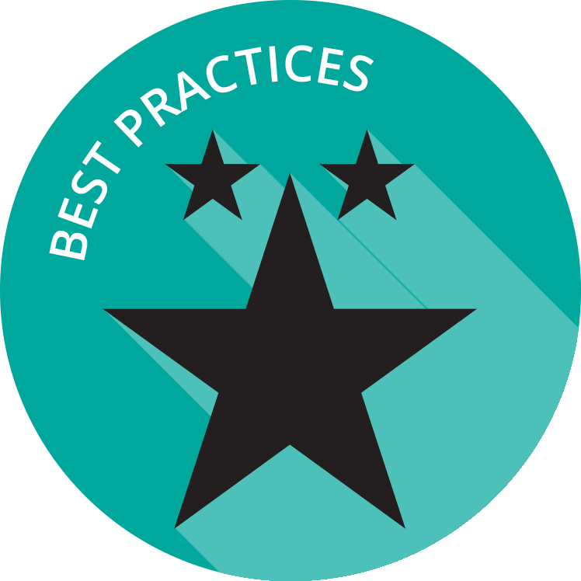
Exemplar Rapid Fire Presentations (15-20 minutes)
Facilitator Note: Ask one or two exemplar schools/districts to share their background and experience regarding collaborative leadership for learning. The presentations should be 5-7 minutes and prepared in advance of the workshop. Additional information about presentations can be found in the Logistics resource.

Discussion Questions
- How is your school/district similar to the exemplar?
- Are there policies/practices shared that your school/district can implement right away?
- What are some of your challenges?

Collaborative Leadership Activity (20-25 minutes)
Facilitator Note: The facilitator introduces the Share and Move activity to delve into collaborative leadership or chooses another activity from the Activity Toolbox. Depending on time constraints, the facilitators can choose the small group activity or both the small group and whole group activities.

Small Group (10-15 minutes)
At each table, create an online sharing document using a discussion question from below. Each table selects a participant to answer the question and the next participant adds to the response. Each person has a few minutes to think about and add their response. Participants should read the comments from other participants to build upon the ideas.

Whole Group (10 minutes)
After the tables respond to the questions, the facilitator brings the group together to discuss the comments from each table.

Discussion Questions
- How does collaborative leadership support the behavioral responses of teachers and students to the roll-out of new initiatives?
- What would teaching and learning look like if leaders from academics, assessment, technology, and finance collaborated on aligned digital learning solutions?
- How does the school or district create an environment that supports risk taking and innovation while remaining accountable?
- What is your collective vision and implementation plan for learning in the digital age?

Policies and Initiatives (5-10 minutes)
Facilitator Note: Discuss how state and local leaders can build capacity for collaborative leadership by coordinating efforts and engaging in strategic planning. These questions can also be used as key topic areas for follow-up workshops.

Discussion Questions
- What are the key policies and practices that need to change in your school or district to realize your shared vision?
- How can your district/school build educator capacity to implement digital learning pedagogy and practices?
- How can the district employ a cycle of transformation to ensure continued improvement?

Reflection and Wrap Up (5 minutes)
Facilitator Note: Take a few moments to reflect on the session, share details about additional events related to the remainder of the day and engage the participants to take action when they return to their schools/districts. Use this activity or choose another one from the Activity Toolbox.

Circle, Square, Triangle Activity
By table, ask participants to discuss where they are in the process using the reflective concept of circle, square, triangle.

Circle – You are still circling these ideas in your mind
Square – You understand the challenge
Triangle – You are ready to implement change

Based on the reflection activity, identify the next steps for your state, district or school.

Wrap Up
Facilitator Note: The facilitator wraps up the day and shares resources with participants. Sample language: “This is only the first step of many steps in supporting teachers and students for learning in the digital age. I encourage you to follow up on our reflection activity during the next few weeks and continue to collaborate with your peers. Think about what tools and resources you can use to maintain relationships and encourage collaboration, as well as identify opportunities for on-going professional learning and workshops.

Resources
The US Department of Education does not endorse any resources; instead they are provided to assist the facilitator in preparing for the workshop. The facilitator can also share these resources with participants to support on-going professional learning and school/district planning after the workshop. For example, some districts have used the NETP for on-going book studies throughout the school year to support the development and refinement of technology initiatives.

US Department of Education Resources
#NETP16: Setting a vision of equity, active use, and collaborative leadership

2017 National Education Technology Plan Update (NETP)

Every Student Succeeds Act (ESSA)

Office of Educational Technology

Office of Elementary and Secondary Education Resources

Transforming Digital Learning: Activities
Transforming Digital Learning: Logistics
Transforming Digital Learning: Toolkit to Support Educators and Stakeholders

Facilitator Guide Resources

Interactive Planning Dashboard

ISTE Essential Conditions

On the Same Page 2.0

Road Map for 21st Century Learning

