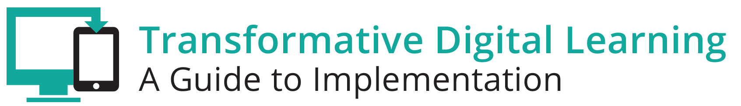

Business/Community Communication Packet
This communication packet includes sample customizable templates where you can add your logos and modify the content to meet your needs. It includes
- Newsletter/website snapshot
- Presentation slides
- Sample tweets
- Press outreach
- Email outreach

Newsletter/Website Snapshot
Technology is not an afterthought for any business--all professions are expected to understand and implement technology tools and resources from clerks to mechanics to artist to engineers to physicians. As schools move towards digital learning environments, it is necessary to foster business and community support to advance the transition and ensure that students are career and college ready. Specifically, educators can share with local businesses and the community some of the benefits of learning in a digital environment, while also addressing some specific areas of interest for businesses and the community. Find out more about learning in the digital age by accessing the Transforming Digital Learning Business/Community toolkit.

Presentation Slides
http://www.setda.org/dlearning/wp-content/uploads/sites/15/2018/03/Business-Community-Presentation.pptx

Sample Tweets
Learn more about the role of business/communities in the digital age [website tiny url] #edtech

Access the Transforming Digital Learning Business/community toolkit [website tiny url] #edtech #[your organization]

Business and schools work together. Transforming Digital Learning Business/Community toolkit #partnership #edtech

Press

Dear [Press]

We are pleased to share with you the Transforming Digital Learning Business/Community toolkit. Technology is not an afterthought for any business--all professions are expected to understand and implement technology tools and resources from clerks to mechanics to artist to engineers to physicians. As schools move towards digital learning environments, it is necessary to foster business and community support to advance the transition and ensure that students are career and college ready. Find out more about learning in the digital age and the role of businesses and the community by accessing the Transforming Digital Learning Business/Community toolkit. The toolkit highlights some of the key areas of interest for businesses and the community, including collaborative leadership, community partnerships and the homework gap. We encourage you to find out more about learning in the digital age by accessing the Business/Community toolkit.

Thank you,

[Business/community organization/association}

Email

Dear [Business/community]

We are pleased to share with you the Transforming Digital Learning Business/Community toolkit. Technology is not an afterthought for any business--all professions are expected to understand and implement technology tools and resources from clerks to mechanics to artist to engineers to physicians. As schools move towards digital learning environments, it is necessary to foster business and community support to advance the transition and ensure that students are career and college ready. Find out more about learning in the digital age and the role of businesses and the community by accessing the Transforming Digital Learning Business/Community toolkit. As you explore this toolkit, you will find information, tips and resources in each of these key areas of interest for businesses and the community--collaborative leadership, community partnerships and the homework gap.

We encourage you to share this valuable resource with your colleagues. You can learn more about Transforming Digital Learning on the website.

Sincerely,

[Business/community organization/association]

